# **This is a manual for KMBOX, with a table of contents on the left.New entrants are advised to read it carefully.Our Q group is 190702064.It has a rich script demo in it.Welcome inside to discuss.If you have any good ideas, you can also raise them.Thank you very much!**

# **Kmbox profile**

Kmbox is a small but powerful USB development board.It is a pure hardware USB master/slave device controller.It can simulate and control USB devices such as keyboard and mouse at full hardware level.It does not need to install additional drivers.There is also no need to inject DLLS.Its script completely out of the PC, running on the CPU of the board, can easily let ordinary keyboard and mouse (non-macro keyboard and mouse) have the programmable function (macro function).All you need is a simple Python call to turn ordinary keyboard and mouse into magic.With it, you can quickly make pure hardware physical plugins.Safe, efficient, not afraid of detection.Not only that.He can also give you a quick introduction to Python.Learn to program and play with hardware.Play as you learn.Use as you play.Lots of fun!Down to the bottom of the sea to catch turtles, up to the nine days of the moon.No matter the hardware logic at the bottom or the framework application at the top.Kmbox can accompany you all the way to fight strange upgrade.An absolute boon for DIY lovers!

## **Kmbox physical image -**

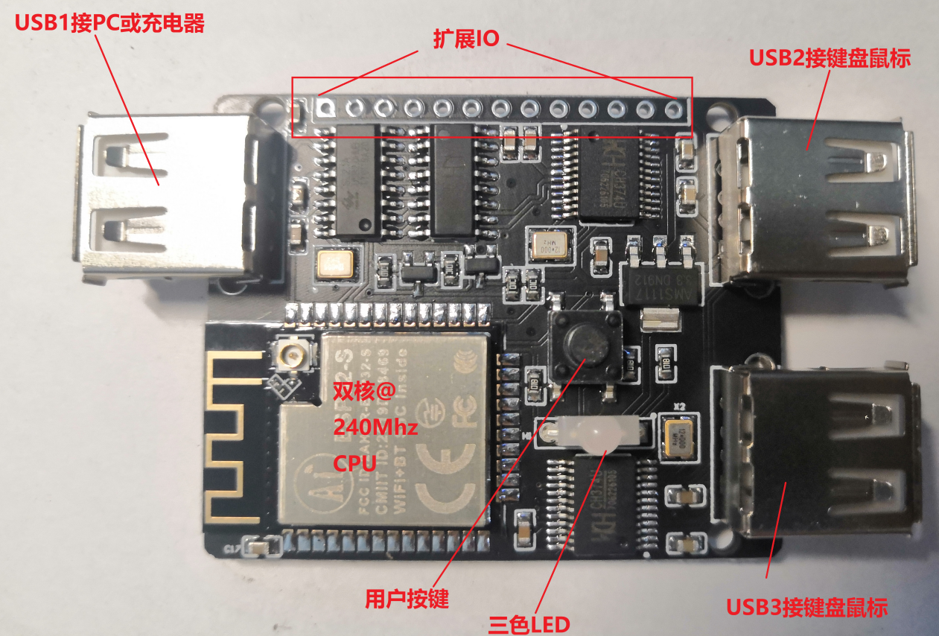

Front default pin is soldered (DIY Extension IO)

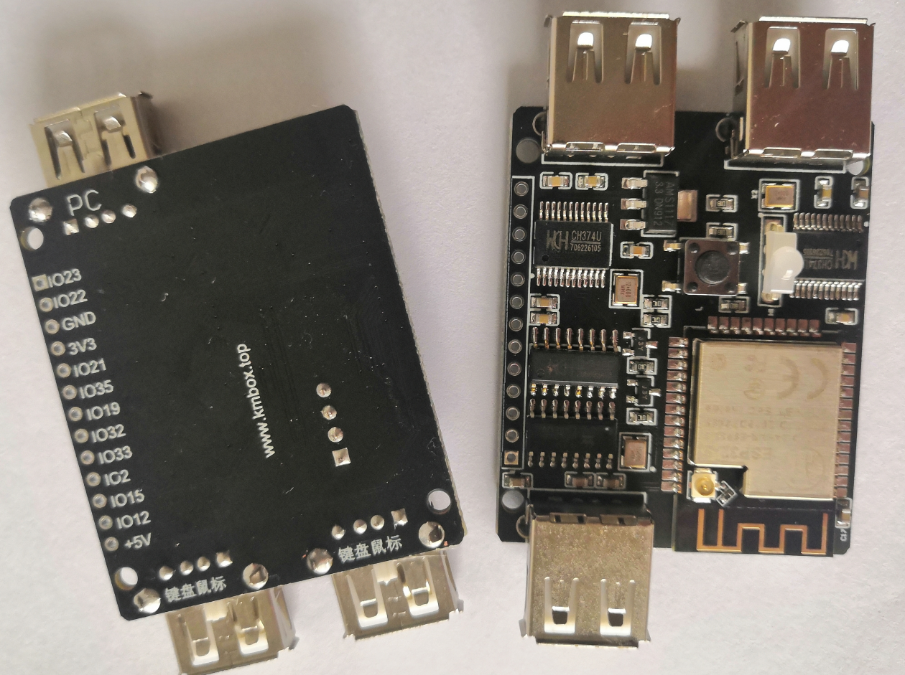

AB face

## **Kmbox hardware features**

The Kmbox contains a dual-core CPU, 3 USB hardware ports.A three-color LED, and a user key.And a set of GPIO expansion ports.The functions of each section are detailed below.

## **USB1 port features**

The USB1 port can be connected to a PC or charger for powering the board.When connecting to PC and other host devices.The Kmbox will automatically enumerate into a standard keyboard and mouse.PC automatically identifies without any driver (keyboard and mouse are standard HID devices, the system comes with its own driver.).And the keyboard and mouse KmBox emulates is no ordinary keyboard and mouse.It's a high-return keyboard and mouse.Here's how KMBox's simulated keyboard compares to a normal keyboard's key parameters:

### **Kmbox keyboard features comparison**

|  |  |  |
| --- | --- | --- |
|  | Kmbox - the keyboard | Other keyboard |
| Rate of return | 1 (1000 ms/S) | 10 ms (100 times/S) |
| The report format | 1+10 keys (can be customized for any key without punch) | 1 + 6 buttons |
| The BIOS mode | Not supported (disdains support) | support |
| The length of the endpoint | 64Byte | 8Byte |

Table 1

1. The rate of return is the interval at which the keyboard is polled by the host.

A shorter interval means more reports and faster keyboard hardware.A regular keyboard is 10ms and reports 100 times per second.Kmbox is 1ms with 1000 reports per second.Performance beats them by 10 blocks.

1. The report format is the number of unpressed keys a packet of data can send.

The conventional keyboard is 1+6 mode, which belongs to 6 keys without flushing, and the KMbox is 1+10, which belongs to 10 keys without flushing (PS: if you want to, you can make the KMBox 108 keys without flushing.But that is not necessary, after all, we only have 10 fingers).

1. The endpoint length is the size of the data hardware buffer.

It determines the maximum number of bytes the keyboard can transmit at a time.A normal keyboard has 8 bytes.The Kmbox has 8 times the buffer of a regular keyboard.More extensions are supported.

To give you an idea of what these parameters mean, imagine typing "1234567890".

Regular keyboard: first packet 123456--> host receives 10ms --> second packet 7890--> host receives 10ms --> end

Kmbox keyboard: First packet 1234567890--> Host receive after 1ms --> End

As you can see, the same operation takes 20ms for a normal keyboard, but only 1ms for KmBox.If you feel like 20ms doesn't count as a gap.Then look at the technical parameters of the mouse.

### **Kmbox mouse features comparison**

|  |  |  |
| --- | --- | --- |
|  | Kmbox - mouse | Other mouse |
| Rate of return | 1 (1000 ms/S) | 10 ms (100 times/S) |
| The key number | 8 keys (left center right +5 side keys.Any key can be customized) | 3 Keys (left middle right button) |
| X coordinate range | -32767 ~32767 (can be customized) | - 127 ~ 127 |
| Y-coordinate range | -32767 ~32767 (can be customized) | - 127 ~ 127 |
| Scope of roller | -127 ~ 127 (can be customized) | - 127 ~ 127 |
| Reports the length of the | 6 bytes (optionally customizable) | 4 bytes |

1. Rate of return:

The KmBox returns 10 times faster than the average mouse.Therefore, it is more responsive and faster, with lower latency.

1. The key number:

Kmbox has five extra side keys by default in addition to the regular left-center right button.Why do you use to explore (PS: can customize any number of buttons) your mouse does not have side keys, access to KMbox is equal to 5 side keys.

1. XY coordinate range:

The Kmbox's XY coordinate range is 256 times that of a normal mouse.

Here's another example to see the difference:

Suppose the mouse moves from the bottom right corner of the screen (1920x1080) to the top left corner of the screen (0,0).The maximum X a normal mouse can move at a time is 127.Then moving 1920 units would require 1920/127=15.118.Rounding it up is 16 times.The time interval between one report is 10ms.Then 16 times would take 16*10ms=160ms.

The XY coordinate range of the Kmbox is plus or minus 32767.So moving 1920 only takes 1 packet of data.That's just 1ms of time.This should give you a sense of what the hardware gap is.One is 160ms and one is 1ms.Do you have the feeling of love?

## **USB2, 3 port features**

The front USB1 port is used to simulate USB devices.Now the USB2, 3 ports are used to connect USB devices.In this case, the Kmbox is the USB host (equivalent to the computer host).It doesn't matter what your USB2 or 3 port is connected to.All belong to my Kmbox tube.Kmbox has the final say on whether and how the external device works.USB2 and 3 ports theoretically support all types of USB2.0 full speed devices.

Currently KMBox takes over the peripherals as USB keyboard and mouse by default (customize it if you want to control other peripherals).In other words, if the keyboard and mouse are connected to the Kmbox.He can access all the data of the keyboard and mouse in real time.If KmBox does something in the middle with the underlying data.You can do some unexpected things.Like changing keys at will, regrouping at will.Any shielded key, any logical judgment, keyboard connected dots, mouse connected dots and so on.Kmbox will modify the data through the USB1 port (or Bluetooth) to the PC.You can make ordinary keyboards and mice have programmable macros.See the KMBox Tutorial Keyboard and Mouse Macros section for details.

## **The CPU features**

Inside the Kmbox is a domestic high-speed dual-core CPU running at 240MHz.Python scripts run on it.The CPU internally integrates Bluetooth and wifi capabilities.You can let the wired USB keyboard and mouse fly through the Kmbox.Bluetooth the wired keyboard and mouse.Connect it to your phone, tablet, or computer.Here are the CPU specifications:

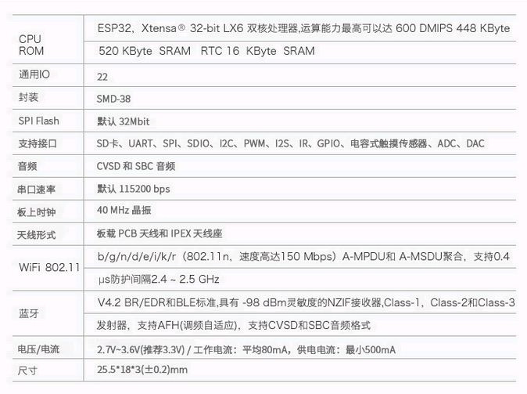

Note: Since the normal USB port power supply current is only 5V@500mA, the KmBox requires a power supply current of 3.3V@500mA.

Some hosts may have insufficient power supply current.As a result, the KMbox works abnormally.Therefore, KMBox turns off Bluetooth by default to reduce power consumption.If you need to use Bluetooth, ensure that the power supply is sufficient.Software script on, see Bluetooth section for details.

## **DIY Extension Features**

The Kmbox comes onboard with a three-color LED for easy script runtime to provide an intuitive status display.The three-color LED is controlled by PWM, which can realize the color modulation of any duty cycle, and the modulation depth is 13 bits.That is, the accuracy of RGB is 13:13:13. It can support up to the 39th power of 2 colors.The three LED GPIOs can be released by script (see rgb_free function for details).Can be reused for other functions.

Kmbox provides a key switch by default, and you can script this IO to any function you want.There is also a set of GPIOs that advanced script players can use to connect to various modules and do various physical plugins.They can also be used to quickly verify hardware modules.Drive various ics,DIY various smart hardware.See the Hardware Extensions section for details

## **Kmbox Software Features**

1. Kmbox has a built-in Python interpreter.Python is definitely a no-brainer programming language.
2. Kmbox has a built-in keyboard and mouse control module (KM) that only requires simple API calls for powerful keyboard and mouse macros and other functions.
3. Kmbox supports conditional judgment, variables, loops, multi-threading and other Python syntax.
4. Kmbox supports communication with the host computer.You can communicate with KmBox through the serial port.For example, the upper computer can find pictures and colors, etc.
5. Kmbox is currently compatible with all Windows and Linux hosts.The kind that works with a drive free plug.
6. Kmbox supports file system management, you can store multiple scripts on the board, as you want to call.
7. Kmbox firmware updates.No other tools are required.The board comes with a download circuit.Simple and convenient.

## **Kmbox typical application**

The cowhide is not blown and the train is not pushed.Here are a few examples of what Kmbox can do.At its core, Kmbox controls keyboard and mouse data at will.So as long as the keyboard and mouse can achieve the Kmbox can achieve.

1. Smart auxiliary keyboard macros
   1. Key Connected click Macro (click me to watch video effects)
   2. [Auto Shout Macro (click Me to watch video effect)](https://www.bilibili.com/video/BV1dJ411m7bQ/)
   3. Keyboard Change Key Macro (click I watch video effect)
   4. ...
2. Intelligent auxiliary mouse macro
   1. [Eat chicken Pressure gun Macro (click me to watch video effects)](https://www.bilibili.com/video/BV1Ya4y1Y7ku/)
   2. [Left click Connect Macro (click me to watch the video effect)](https://www.bilibili.com/video/BV1Vg4y1q7pm/)
   3. [Mouse Drawing Macro (Click Me to watch video effects)](https://www.bilibili.com/video/BV1YJ411X7cM/)
   4. [Mouse Precision Control Macro (click Me to watch video effects)](https://www.bilibili.com/video/BV1Sh41197q6/)
   5. ...
3. DIY extensions
   1. [USB Wired Keyboard and Mouse Bluetoothed (click me to watch video effects)](https://www.bilibili.com/video/BV18i4y1x7hk/)
   2. [USB gamepad Bluetooth to play King of Glory (click me to watch video effects)](https://www.bilibili.com/video/BV1TJ411674d/)
   3. [Wireless mouse to control the car](https://www.bilibili.com/video/BV1aK4y1h7oi/)
   4. WIFI probe (link)
   5. Weather forecast (link)
   6. Iot Switch control (link)
   7. ...

## **Kmbox characteristics**

1. security

For a computer, the KmBox is a clean standard keyboard and mouse.A standard HID device that doesn't require any drivers.The computer recognizes it automatically.By no means those software macros, driver macros can compare.Put an end to the risk of account theft from the source.

1. efficient

Standalone dual-core CPU with 240Mhz super high main frequency.Strong data processing capability and efficient script execution speed.Does not occupy PC host CPU time.Its performance is equivalent to 2.4G dual-core CPU with 10% of the performance dedicated to handling the keyboard and mouse.The performance is absolute bar!

1. simple

Kmbox uses the flexible Python3 script.Powerful KM module built in.Support conditional judgment, variables, loops, multithreading.Small white white can easily write hardware plugins through simple API calls.Python is widely acknowledged as an easy to read language.

1. practical

The Kmbox is a tool that can turn the average keyboard and mouse into something magical.With his ordinary keyboard several times can change the key at will, control at will, mouse connected point, keyboard connected point, mouse macro, keyboard macro.Eat chicken pressure gun, automatic brush strange, one key N skills......Complete control of all keyboard and mouse data.You can even Bluetoothize the common keyboard and mouse.Wirelessly connect to computers, cell phones and other devices.

1. bullying

Bully is that KMBox can directly improve keyboard and mouse hardware performance by 10 times.Regular keyboard and mouse 10ms reporting interval, 100 times per second.Kmbox has 1ms reporting intervals, 1000 per second.After you connect the KMbox, you can overclock your keyboard and mouse device.10 times faster than the rest of the world at all times.

1. Inside collect

While being domineering, you will find a low-key and reserved side.It has 4 megabytes of storage, can hold 4 million lines of logical code, and supports file system management.It is very suitable for system learning USB, learning Python, learning software and hardware.It can be attached to a variety of peripheral modules, unlimited expansion, as you DIY.It can do whatever you want with it.

# **Kmbox Basics tutorial**

Some basic ways to use KMBox will be covered here.After reading this chapter, you can start your life.Cut the crap and get to the point.Please refer to all pictures in kind.

## **Split open a case**

* The accessories list is as follows:

|  |  |  |
| --- | --- | --- |
| The name of the material | The number of | note |
| Kmbox core board | 1 | VerB |
| USB extension cord | 1 | Length of 1.5 meters |

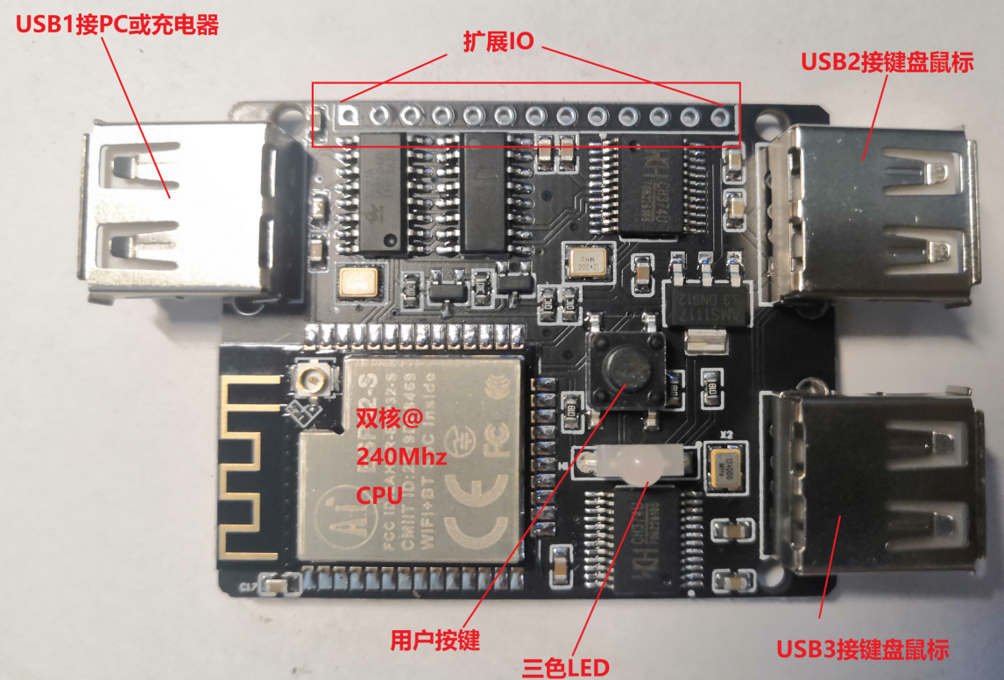

Kmbox core board

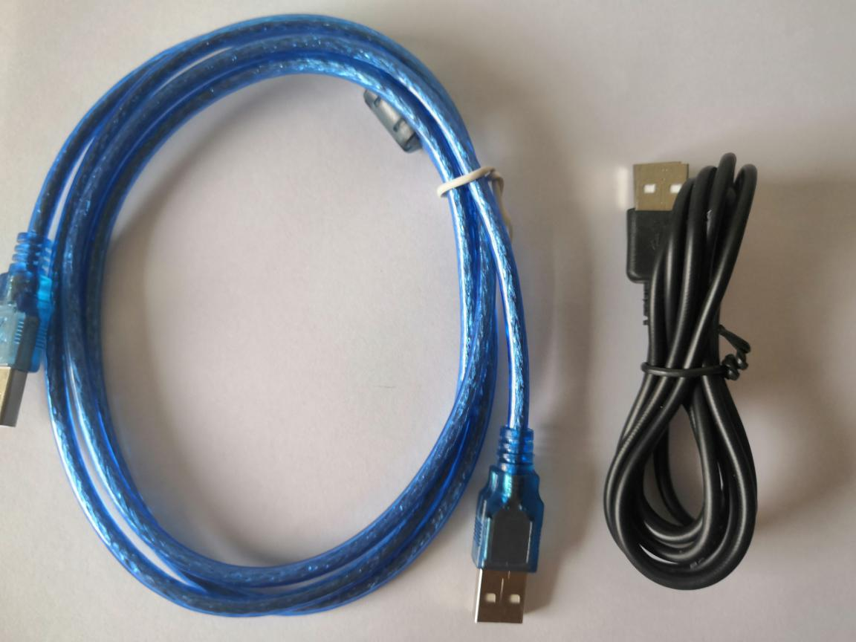

USB extension cable (one of two blue and black wires, shipped without note)

## **Connect the computer**

Start by connecting one end of the USB extension cable to the USB1 port of the Kmbox.Connect the other end to your computer's USB port.Wait for a moment.You'll see these in Device Manager:

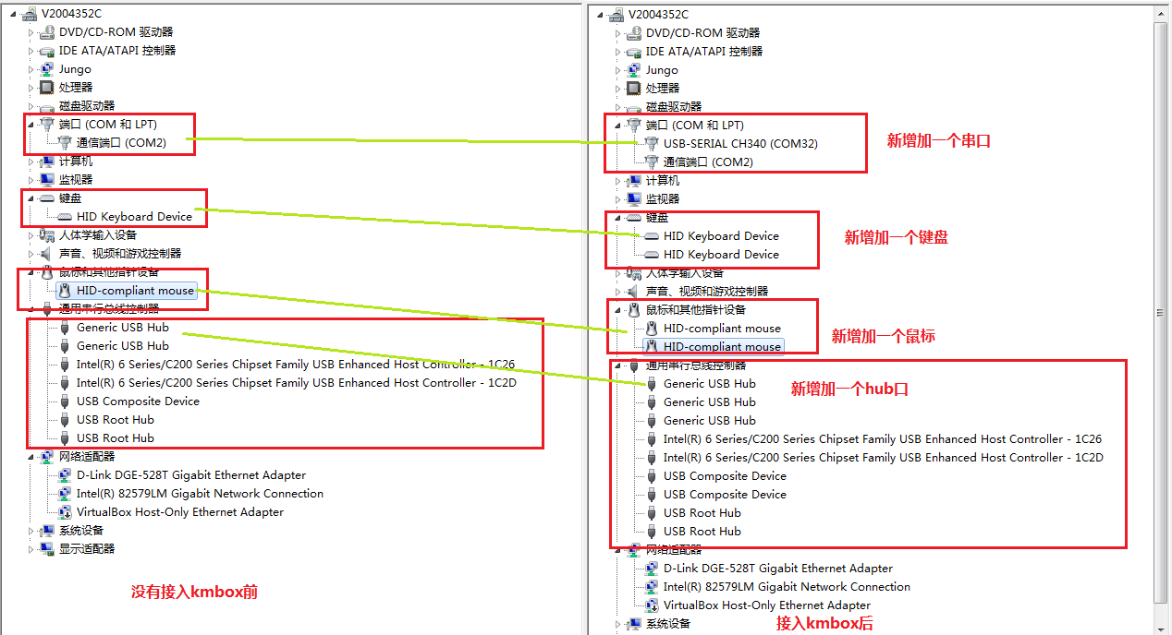

4 hardware devices will appear by default when Kmbox is connected to a PC.These are shown in the image above:

1. Serial port (important)

The communication between Kmbox and the host is done through the serial port.If no serial port appears, install a serial driver.Serial port drivers are used to debug code and download scripts.It is not required.But you do if you want to play programming and debugging.Otherwise, how can code be downloaded and run on the board?The driver is just a communication port.Those of you who have played embedded will be all too familiar with it.When the serial driver is installed, you can log in to the board using any serial debugging software.

You can start your life from this serial port.(Drive please go to group sharing download Q group: 190702064)

1. A keyboard (automatically generated)

He is a real keyboard. [See Table 1 for detailed specifications of Kmbox keyboard.](_Kmbox键盘特性对比)

1. One mouse (automatically generated)

This mouse is also the mouse generated by KmBox's automatic enumeration.Real physical device.

[.See Table II for detailed specifications of Kmbox mouse.](_Kmbox鼠标特性对比)

As shown in table 2.

[.See Table II for detailed specifications of Kmbox mouse.](_Kmbox鼠标特性对比)

4. A HUB HUB

The Hub Hub is used internally by KMBox for keyboard and mouse data channels and board debugging transfer upgrades.

## **Login kmbox**

You can log into KmBox with any serial port tool.Common serial port tools are SecureCRT, UpyLoader, and serial port debugging assistant.Use whichever one you are familiar with.Here I use the serial port tool is Putty, only a few tens of KB small!It's very nice.Take putty as an example to introduce a simple development process.Other tools are similar.

Double-click the Putty.Follow the steps below to fill it in, then click Open

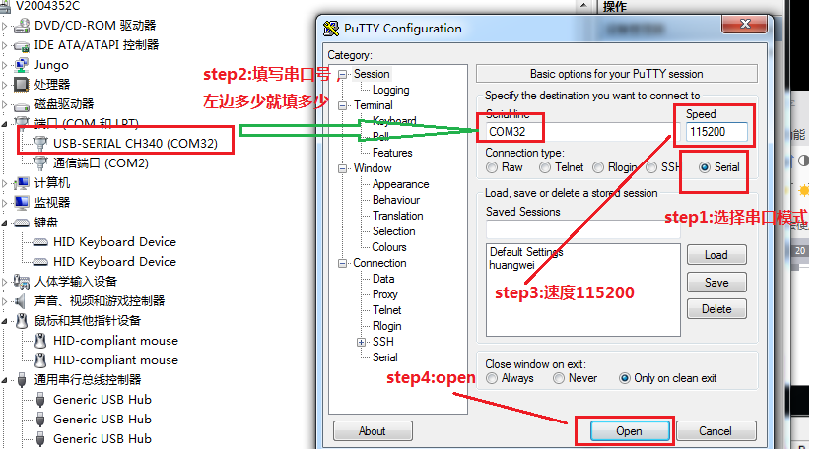

After Open, you can type Enter. The symbol ">>>" will appear, indicating that you have successfully communicated with the board.You can type "help()" and press enter to see the help information inside the board.This is shown in the image below:

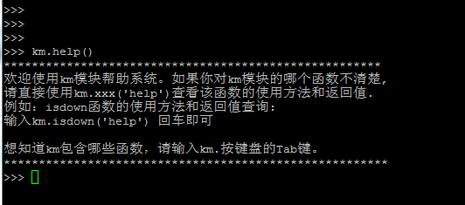

Here is the running Python environment inside KmBox.You can write any algorithm or function you want, following Python's syntax.Don't be afraid if you've never learned to program.To tell you the truth, Python is really easy.It's really easy!It's really simple!Don't scare yourself.As long as you can type.You can program.If you have Python basics, ask the upper right X to go straight to the next chapter.If you are a small white please continue to read.

B: Well, now that you've seen this.Then give you two bows.Warmly welcome Xiao Bai into the pit.This will teach you how to control KmBox using Python scripts in the most straightforward way possible.The programmer's first code is Hellow World.So let's start with Hellow World.It only takes one line of code:

Is it simple.You actually know how to print.You'll have a good idea of how the code is working.Adding Print to the debugging phase will help you debug your code more efficiently.

Here's a pure software example, let's do a more hardcore hardware example.How to control hardware with code.See the green LED lights on the board?Now control him with Python.It's all about being practical.No fancy code.Light up an RGB function.

Remember what I said earlier?Python is easy. Anyone who can type on a keyboard and read text can program.Follow me!!!!!!!On putty's interface type "km.RGB (' help ')" and press Enter!Don't ask why yet, just type.Here's the screenshot:

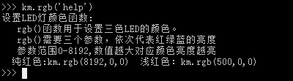

Above is the help document for the RGB function.It's written very clearly.Solid red: km.rgb (8192,0,0) will do

Here you might ask what is KM?Point is what?RGB is what?What are curly braces?What's a comma?Nothing!!That's how programmers get over it.I now simply say, do not understand it doesn't matter, anyway, as long as you know is so use!Use more you will know naturally.

"Km" is module.Python works because there are a lot of rich modules.You can hit the TAB key to see which modules are currently available.

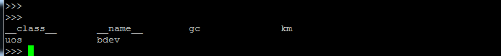

The GC module, KM module, UOS module, BDEV module are currently loaded.

"." "Is a function in the module, for example we want to see what functions are in km we can type" km. "and hit TAB.

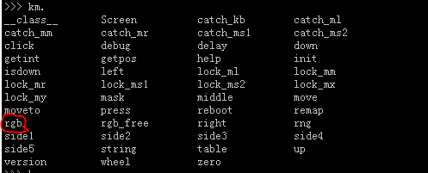

All the functions in the Km module are here.Did you find any RGB functions?

"RGB" is the function inside the KM module.All functions are in parentheses.Don't ask why.Because is the rule.

", "is the separation between function arguments.Now see what it means to ask you to type km.help()?Call the help function in the km module.RGB (100,0,0) calls the RGB function in the km module and sets the value of R to 100 and G and B to 0. This will make the LED light red.

Think outside the box, green, blue, purple, cyan and other colors?Then change the value of RGB.Everyone knows the principle of primary colors.The range of RGB is stated in Help to be 0-8192. You may be wondering, what does this value have to do with brightness?It's a long story.There's circuit knowledge, there's hardware knowledge.It's all low-level.In the embedded domain, there are two layers: the bottom layer and the application layer.You can learn a lifetime in each area.I have already wrapped the RGB function for you.All you have to do is call this API.We can change the light color just by remembering the RGB function.Don't worry about the rest.

It is highly recommended that you leave putty on and follow the tutorial by typing the code word by word.It will look even better!

So to abstract, just know what each function does.Then you can use KmBox well.In fact, most programmers today are like this.Read the API documentation.Write test code.Like when we buy a car, we don't know how the wheels are made or how the engine works.Read the instructions and just know that you can turn the key to start the car, turn the steering wheel to make a turn, and shift the gears to change the speed.Familiarize yourself with these human-machine interfaces and you'll be able to operate your car.Older drivers may not be able to build cars, but they will be able to drive them.Similarly, familiarity with these API functions will help you use KmBox well.How well you drive and how well you use Kmbox depends on how you older drivers operate these apis.

Well, by the end of this chapter you have entered the world of Python programming. Here's how to write keyboard and mouse macros using Kmbox.You'll learn more about all of KmBox's apis in the following sections.I'll introduce you to these apis in a teach-it-once, do-it-yourself manner.Learn as you play.It's all actual code.Tangible results.It's fun to learn and play!

# **Keyboard macro programming**

Ladies and gentlemen, welcome to this chapter.Don't get the board and think about the whole awesome plug-in.Let's just calm down.Let's start with the basics of keyboards.Don't underestimate theoretical knowledge.These basic theories will save you many detources later on.

## **Keyboard Facts**

Let's start with a simple fact about how a computer recognizes the keys on a keyboard or mouse.

In a USB system, all data communication is initiated by the host computer (PC).Such as pressing a key on a keyboard.It is not the keyboard that actively sends the key value to the host.The host actively comes and reads which keys the keyboard pressed (highlight).This is the most basic feature of USB systems.This is true of all USB devices.Communication between the host and keyboard is similar to this pattern:

Host: Keyboard Do you have keys?

Keyboard: No!

After a while....(Host waits for a polling time)

Host: Keyboard Do you have keys?

Keyboard: No!

After a while....(Host waits for a polling time)

Host: Keyboard Do you have keys?

Keyboard: I pressed 123456789

...

Can see from the above model, USB devices belong to from the device.The PC is the master device.The master device and the slave device communicate with each other in a question-and-answer manner.Then you may have questions.When does the host read the keyboard data?How often does it read?I'll give you the answer directly, the value will be defined in the configuration descriptor of the USB device.The above "After a while...."Which corresponds to this polling time.Usually, the low speed devices such as keyboards and mice are 8ms-10ms (see the USB protocol documentation, HID documentation for more information).That's 100 to 125 reads per second for the host.Remember, this is the general regular keyboard and mouse reporting time.The smaller this number, the more frequently the host reads the data.The more responsive it is.High-speed USB devices are 125US read once.But smaller is not always better.Because if you think about it, keyboards and mice are physical devices.Can you press the keyboard 50 times or the mouse 50 times a second?No way!If the host keeps asking, but the USB device keeps saying no no.It's also a waste of the host's time.From here you can see that the performance of a keyboard should mainly include the following two factors:

1. The rate of return.

That is, the polling interval for the keyboard.A shorter interval indicates that the keyboard's hardware is running faster.

Regular keyboards are 10ms and our KMbox is 1ms.The performance is 10 times better than theirs.

1. Report length.

Above I hit 123456789 which is report length.Regular keyboard reports are 6 keys with no flusher.

If you want to send 123456789 pressed, it needs to be sent in two packets.The first packet is 123456 and the second packet is 789.

Kmbox currently uses a 10-button no flush (after all, we have 10 fingers).123456789 can be sent in one packet.Save time.(PS: If you want to be able to do the Kmbox 108 keys without flushing.But you don't have to.)

Would you like to know how long the reporting interval is on your current keyboard?What is the reporting format?Very simple.Plug your keyboard into the USB2 or USB3 port of the KmBox.The Kmbox will be automatically calculated based on parameters such as the device descriptor and displayed inside the serial console:

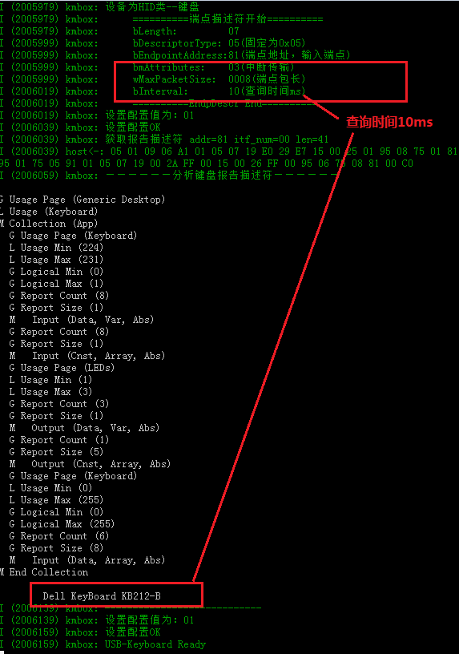

As shown here, the Dell KB212-B keyboard I'm using now.The query time is 10ms.So KmBox will make sure to read the keyboard report data every 10ms.Some people ask.Can the host read faster?Yes, for sure.But you have to remember one thing.It's up to the host to read, and it's up to the device to answer or not.The device has told the host in the descriptor that you had better come to me 10ms to ask for data once, meaning: if you come early sorry I'm busy, your request is too fast, I can't handle it.If you're late, yoo-hoo, last time's data may be washed away.So.The people who do the mainframe should just read it whenever the device asks you to.[To learn more about KmBox's keyboard features, click here to jump.](_Kmbox键盘特性对比)

PS: If your keyboard or mouse can't be used when connected to KMBox, please click here. I can tell you with confidence that there is no keyboard and mouse that KMBox can't handle.

**Also, the printing above is not necessarily a problem.By default, Kmbox acts as a regular keyboard and mouse for unrecognized keyboards and mice.Don't bother with this print if it works fine.**

## **How does Kmbox handle keyboard data**

Having looked at the relationship between universal USB master and slave devices, let's look at the relationship between KMBox and host and keyboard.The Kmbox is strung between a computer and a USB device.This is shown in the image below:

The end that connects to the computer belongs to the USB device.The Kmbox needs to emulate a standard USB device.By default, the Kmbox emulates a keyboard and mouse.The keyboard parameters that Kmbox emulates are listed in Table 1 above.The USB port on the right is connected to USB peripherals.Then the right side of the Kmbox is the USB host role.As a host, KmBox recognizes HID keyboard and mouse devices by default.Kmbox will access and configure the peripherals according to their descriptors.As you can see from the procedure above.

Raw data for all keyboards and mice will go through KmBox.It is then sent to the computer.Imagine running a script inside KmBox, processing raw keyboard and mouse data in real time, and rearranging the packaging according to the logic of the user script.Then send it to the host.For the host PC.He receives the data after the macro processing.And it's real HID data.The logic running inside the script is equivalent to the logic of the external keyboard and mouse.That is, even if the external keyboard and mouse does not have the macro function, KmBox has the same function as your keyboard and mouse.

Take, for example, how Kmbox makes a normal mouse work.Press the left mouse button to fire.If Kmbox does not handle.Then all the PC host receives is a left mouse button press, fire.This is a normal process.But if you connect to KmBox.Write a script like this inside KmBox.If the left mouse button is down, then move the mouse down again.These two types of packets are sent to the host.Firing is what we implement.Mouse down is what the Kmbox script implements.PC doesn't care about any of this.Because it only recognizes HID messages.And HID messages just fire, mouse down.Throughout the process, Kmbox helps us automatically mouse down the gun.It reduces the difficulty of operation. At this point you may have questions.Where do I know how to change the underlying HID data?Don't worry, don't panic, the problem is not big.Kmbox already packs these functions.You just need to know how to call them.It doesn't matter how the bottom layer is implemented.And with that, it's time to start the main content of today.Keyboard macro functions.

The following content while typing the code to see the taste of better yo.You don't have to understand all the functions at once.It's the same to look up which one you use.But only if you know it's there.Be sure to skim through each function at first.Know what they do.Writing your own script will give you an idea of how to write it.The following function description can also be obtained directly by typing km. XXX (' help ') into the code.XXX is the name of the function you want to query.

## **The table function**

Call method: km.table()

Note description: This function is used to display the corresponding table of common keyboard key names and key values.

Because PC recognition keys only recognize the HID data key value, this function is used to query the physical keys on the keyboard corresponding to the decimal value, so if you need to query which key corresponds to which key value.You can directly call km.table() to view.The following is returned:

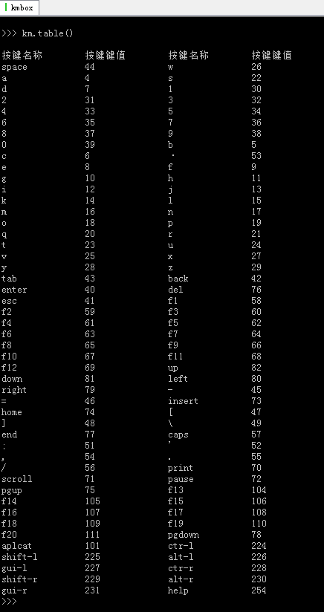

As shown:

The space bar name is "space" and the corresponding encoding value is 44.

The enter key name is "Enter" and the corresponding code value is 40.

You don't have to memorize the key value, just look it up when you use it.It is also supported if the key you want is not in the list.The power key, for example, has a value of 0x66. We just don't use it often enough to write it in this table.

[Click here to see the full key table.](_附录1.键盘全键值对应表)

## **The down function**

Call method: km.down(value)

The down(value) function is used to control the keyboard key press down and is equivalent to manually pressing the physical key.The value can be a number (e.g., the A key value 4) or a string (' A 'string).A numeric type is recommended.More efficient.Refer to the km.table() function for the value of value.Down () is generally used with the up() function.

For example, if you want the keyboard A key to stay down, you can write it in two ways:

1. Km.down (' A ') ---- Type the name of A directly, and this name is the key name in Table ()



Note that typing the above command will keep printing A. To stop, press CTRL +C.

1. Km.down (4) ---- Enter the key value (4) of A directly. This key value is the key value in Table ()



The down function uses a script to control the press of the key. Even if you do not physically press the key, if you call km.down(' a '), then the PC will recognize the press of A key.

PS: If you are in the console, you can press CTRL + C to stop the script from running.

The instructions for using the Down function are as follows:

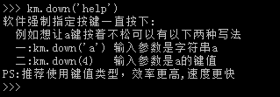

## **Multidown function**

The multidown function is used the same as the down function.The only difference is that the multidown function allows you to press multiple keys at once.Up to 10 keys can be pressed simultaneously (up to 10 arguments).

For example if you want to call Task Manager, the shortcut keys are CTR-L (left CTRL)+ AlT-L (left Alt)+ Delete key.You could write something like:

Method one: km. Multidown (Alt -l 'CTR - l', ' ', 'del') - the character directly

Method 2 of 2: km.multidown(224,226,76) ---- directly pass the key value

Note that Multi Down is generally used with multiup.

## **The function of up**

Call method: km.up(value)

Up (value) is used to set the keyboard to lift the specified key, which is equivalent to manually releasing the physical key. Value can be a number (e.g., the spacebar value 44) or a string (the 'space' string).A numeric type is recommended.More efficient.See km.table() for the value of value, which is generally used with the down() function.

For example, you can release the space bar in either of the following ways:

1. Km. up(' space ') ---- Enter the name of the space bar directly. This name is the key name in table()

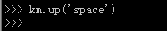

2, km. up(44) ---- Enter the key value of the space bar directly. This key value is the key value in table()

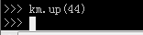

After km. up(44), the space bar is pressed and the cursor does not move further.

PS: This function is equivalent to releasing the specified key. Even if you physically hold the space bar tightly, the space bar will release after the function is called.

The instructions for the Up function are as follows:

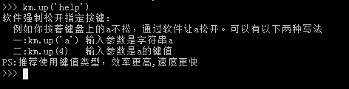

## **Multiup function**

The multiup function is used the same way as the up function.The only difference is that the multiup function supports lifting multiple keys at once.Up to 10 keys can be lifted at the same time (up to 10 arguments).

For example if you want to uninvoke Task Manager, the shortcut keys are CTR-L (left CTRL)+ AlT-L (left Alt)+ Delete key lift.You could write something like:

Method 1: km.multidup(' CTR-l ', 'alt-l', 'del') ---- Pass characters directly

Method 2 of 2: km. multidup (' Ctr-l ', 'alt-l', 'del') ---- Directly pass key values

Note that Multi Down is generally used with multiup.

## **Press the function**

The press(value) function is used for a single keystroke on the keyboard, which is equivalent to manually clicking a physical key once.Value can be a numeric or string type (numeric type is more efficient). For the value of value, see km.table().This function is equivalent to calling down() and then up().

For example, you might want to press the 'A' key on your keyboard.It can be written in one of two ways:

1. Km.press (' a ') ---- Enter the name of A directly. This name is the key name in table()

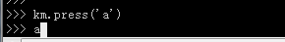

2, km.press (4) ---- Enter the key value of A directly. This key value is the key value in Table ()

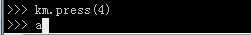

The press function can also take two or three arguments that specify the time to press the specified key, which can simulate manual action.

For example, press the A key for 200ms, you can write: km.press(4,200)

200 here refers to holding down the A key for 200ms, which is mainly used to simulate releasing after holding down the A key for 200ms.

Can also take three parameters: km.press(4,80,100)

The 80, 100 here refers to a random value between 80 and 100ms for how long A continues to hold down.It is mainly used to simulate human operation.If you do not take parameters, KmBox will execute a key as fast as possible.Generally 1ms time.It's impossible for a normal person to do this, and with parameters, it will make your script feel more human.You can pass behavior detection.Please pay attention to the rationality of the time parameter, the detailed usage of press can be queried km.press(' help '):

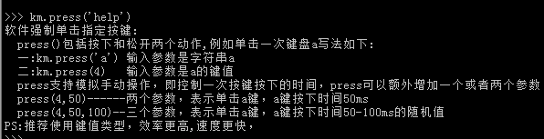

## **Multipress function**

The multipress function is used the same way as the press function.The only difference is that multipress supports multiple keystrokes at once.Up to 10 keys can be pressed at the same time (up to 10 arguments).

For example if you want to call Task Manager, the shortcut keys are CTR-L (left CTRL)+ AlT-L (left Alt)+ Delete key.You could write something like:

Method one: km. Multipress (Alt -l 'CTR - l', ' ', 'del') - the character directly

Method 2 of 2: km.multipress(' Ctr-l ', 'alt-l', 'del') ---- Directly pass keys

## **String functions**

The string function is used to simulate typing a string of characters, for example we want to type "Hellow word" directly. The easiest way to do this is to call the km.string(' hellow word ') function, but you can also do h, E, L, L, O, W...Call km.press() one by one.This is actually what String does internally.Here's a screenshot of how it works:

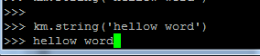

Note: String's strings support numbers 0-9 and all upper and lower case letters as well as characters in the main keyboard area.Keypads are not supported.Because the keypad will conflict with the main keyboard.Note the use of the escape character (\, ', ") when using it.

The String function takes a String argument and supports escape characters (\r(carriage return) \n(space) \t(Tab)), for example if you need to do an automatic login script.Generally, enter account, Tab, password, and enter.This can be done in one step using the string function, for example:

Account: KmBox

Password: www.clion.top

Write it like this: km.string(' KmBox\\twww.clion.top\ r ')

Where \\t and \\r denote Tab and carriage return.(Note that the escape character needs an extra slash)

## **Isdown (connect the detected keyboard to the kmbox)**

The isdown(value) function detects whether the specified value key isdown.Value can be a numeric or string type (numeric types are more efficient). For the value of value, see km.table().This function is mainly used in logical judgment to determine whether a specified key is pressed.

For example, you want to check whether the 'A' key on the keyboard is pressed.It can be written in one of two ways:

1, km.isdown(' a ') ---- Enter the name of A directly. This name is the key name in table()

2, km.isdown(4) ---- Enter the key value of A directly. This key value is the key value in Table ()

There are four return values:

0: Not pressed - None of the physical software is pressed

1: Physical down -- Physical down but software not down

2: Software pressed - Software pressed but physics not pressed

3: Physics and Software are both pressed - software and physics are both pressed

**Here we make a convention that a real keyboard press is called a physical press and a software script press is called a software press.**

**So it makes sense that the isdown function returns four of these values.**

The instructions for Isdown are as follows:

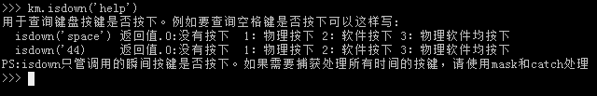

Note: The isdown function detects the contents of the HID report.If your keyboard is not plugged into the Kmbox at all.Kmbox can't detect anything.Don't be naive and think the computer will tell KmBox.If you can, write your own driver.At present, the Kmbox detection function is limited to the keyboard and mouse connected to the Kmbox.

## **Get int function**

This function, like the table function, is used to query the key value corresponding to the keyboard string.For example, if we need to know the value of the "esc" key on the keyboard, we can use table() and find the value of "esc".Another way is to use the getint function.Such as:

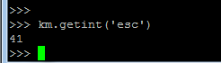

So how can you give birth to Liang if you give birth to Yu?There is no need to use getint if you have a table.There must be a reason for it.Let's start with the following code

Run=getint('f1')

if km.isdown(Run):

km.string("welcom")

else

km.string("good bye")

As shown above, we give Run the key value of the F1 button, and if Run is pressed, we print welcome.Release to print goodbye.

If you want to change the shortcut key, not F1 but F10, the script changes only the string inside getint and nothing else.If you don't have getint. Then you need to change every Run.So the advantage of this is that you can set variables while writing scripts and expose the interface more easily.This is convenient for script generality.

The instructions for the getint function are as follows:

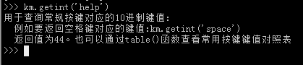

## **Mask mask function (you need to connect the masked keyboard to Kmbox)**

The mask function is used to mask or query whether the physical keys of the keyboard are masked.For example, you want to mask the Enter key on your keyboard.You could write something like:

Km. Mask (" enter ", 1)

The first argument is the string enter. See Table () for details.The second argument is 1. For masking.

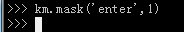

After blocking the ENTER key, the PC will not recognize whether you press or release the ENTER key on your keyboard.You've removed the enter key from your keyboard.Another way to write it is the value of the enter key.



Here 40 is the corresponding key value for Enter.

You can check the status of the masked key (pressed or unpressed) using the isdown() function.

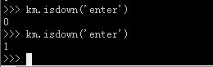

As shown in the figure above, after blocking the return button, press the return button and hold it steady to query through isdown.The return value is 1, indicating that the physical press is down.Pay attention to.Although KmBox will not send the key value to the PC after Mask, it will still receive the key value.This is because we want the physical keys not to affect our script when we are making keyboard links.Let's say you want to make a space dot.Expect to keep pressing the space down and up, because you physically keep pressing the space down.The moment the script software executes UP.The keyboard is loose.But then it's pressed down again.So in order to ensure that the script is not affected by the physical button.You can use the mask function to mask the physical keys.This leaves the status of the space bar entirely up to the software.The physical keys do not interfere with the logic of the script.

If you find that a key doesn't work.First check to see if the key is blocked.Just type:

Km.mask(key name or key value)

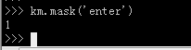

For example, if you just masked and returned a value of 1, it means that the key is masked.To unmask the key, just change the second parameter of mask to 0.

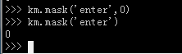

Once unmasked, query the enter again to see if it is masked, with a return value of 0 indicating that it is not masked.Press Enter again and you can use it normally.

There is another more advanced use of the Mask function.It is used to set a key to capture mode.For example, if you want to know how many times the space bar has been pressed, using the normal isDown method may not poll fast enough.This may cause you to miss the detection of specified keys.In this case you can use mask(' space ',2) to set the space bar capture in real time.Make sure you don't miss any keystrokes.You can use the catch_kb function to retrieve the pressed keys.

[The usage of catch_kb is described in the catch_kb section.](_catch_kb捕获按键函数（需将被检测键盘接到kmbox上）)

The instructions for the Mask function are as follows:

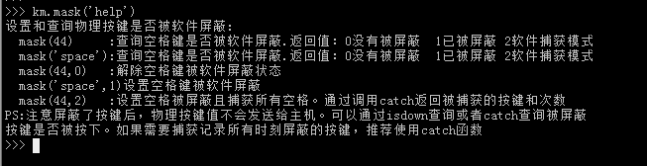

## **Init initializes the function**

The init function is equivalent to restoring the original state where nothing was done and the keyboard and mouse pressed nothing.Because you may be writing scripts that block a lot of keystrokes.This function can be used when you want to release all the keyboard and mouse keys of your script.Avoid resetting the original mask one by one.

## **Media Multimedia function key function**

The media function is used to simulate the function of the multi-function key, your keyboard can be without the multi-function key, Kmbox has is equal to the external keyboard has.This function is called once equivalent to press once corresponding to the multikey.The multifunction key includes the following functions:

1: Volume reduction

2: Volume increases

3: Mute/unmute

4: Pause/Play (general player works)

5: Open your browser

6: Sleep Sleep your computer

7: Shutdown shuts down the computer

For example: You want to turn down the volume on your computer, you can just type km.media(1).As shown below, see km.media(' help ') for details.

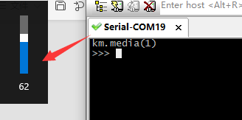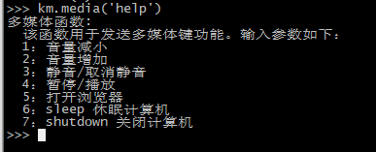

## **Remap key change function (the keyboard to be changed needs to be connected to kmbox)**

Remap is a fun function to use.Commonly known as the remap function.The principle is to press the A key on the keyboard, and Kmbox automatically remaps the A key to the B key.In other words, the function of changing A key is realized.Using the remap function, you can re-customize all the keys on the keyboard.Again, you can't read the help document.

The nice thing about this function is that you can change the key at any time.When you play a game, you often have a problem with the keys.Use this function to change the keys anywhere you want.

## **Catch_kb captures key function (you need to connect the detected keyboard to KmBox)**

The catch_kb function is special in that it is activated only after calling mask(XXX,2).The catch_kb function is used to capture all the keys specified by the mask function.First you need to point out.It takes time for code to run.For example, if you want to check if the A button is pressed.It's natural to use isdown(' a ').Let's say you have a single threaded script.

If isdown(a):

Print (' a is down)

Sleep(10)

This script looks like it's detecting A. but the actual effect is terrible.Because the sleep(10) directly stops the code for 10 seconds.No matter how much you press A for those 10 seconds, the isDown function won't detect it.Because the code is not running to the isdown function.so

The catch_kb function is in.The catch_kb function is activated by calling mask.

First call km.mask(' a ',2).After the Mask function returns, the A key press will be caught in the catch_kb() function.Now you silently count how many times you press A.Then you call km.catch_kb().You'll notice that each call returns a 4, which changes to 0 after 5 returns.(PS: The building master is two keyboards.So call mask and then use the other keyboard input 'a'.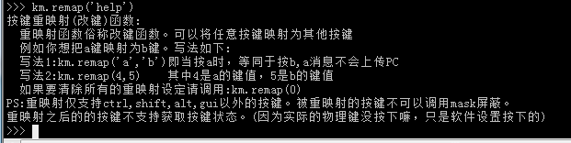Don't hit me.)

Catch_kb can be used as follows:

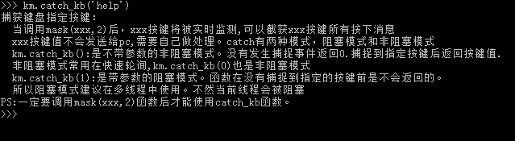

Another use of the catch function is the one-click N skill.For example, you write a logic like this in your script.

If the A key is pressed, then press 12345 successively. There are many ways to implement this logic.

Method 1 of 4: Polling Method

If km. Isdown (' a ') :

Km. String (' 12345 ')

Do something ...

The advantage of this method is its simplicity. The disadvantage is that if you Do something...Takes longer than it takes you to press the button.Then the detection of A may not be timely.

Method 2 of 2: Multi-Threaded Capture

First we turn on A's catch, then enable a thread that executes the catch function exclusively.The main thread executes Do something...This ensures that A's capture will not be affected by do something.Multithreaded methods are covered in a special section later.

The above content is Kmbox for you to provide keyboard related API functions.In fact, the keyboard is also two states, the key is pressed, the key is up.If you have more needs, you can also contact me.Comments are welcome!

# **Mouse macro programming**

After the study of the previous chapters, I think you should have a new understanding of the keyboard now, this section begins to learn the relevant knowledge of mouse macro.First look at the Kmbox simulation of the mouse technical parameters:

|  |  |  |
| --- | --- | --- |
|  | Kmbox - mouse | Other mouse |
| Rate of return | 1 (1000 ms/S) | 10 ms (100 times/S) |
| The key number | 8 keys (left center right +5 side keys.Any key can be customized) | 3 Keys (left middle right button) |
| X coordinate range | -32767 ~32767 (can be customized) | - 127 ~ 127 |
| Y-coordinate range | -32767 ~32767 (can be customized) | - 127 ~ 127 |
| Scope of roller | -127 ~ 127 (can be customized) | - 127 ~ 127 |
| Reports the length of the | 6 bytes (optionally customizable) | 4 bytes |

Return rate: Normal mouse reports 10ms a piece.Our Kmbox is 1ms. We can execute 10 instructions in 10ms.

Key number: ordinary mouse only left, middle and right three in total.Our KMbox has 8 keys (the number of keys can be customized).

Coordinate range: one byte for ordinary mouse.Kmbox is occupied by two bytes.The range span is 256 times that of a normal mouse.

If these parameters you don't see the advantage.Then I'll give you a simple example.On a 1920x1080 monitor.The normal mouse is moved from the bottom right corner of the screen (19201080) to the top left (0,0), calculated as the maximum step 127 (a byte of 8bit, 1bit symbol +7bit(127) data).You need to move the X-axis 1920/127=15.118 times.Rounding it up is 16 times.A normal mouse needs to send 16 packets of data.The interval between each packet is 10ms. It takes 160ms in total.Our Kmbox is X step is 32767. Same movement, only one packet of data is needed.One transfer.It takes 1ms in total.Now you know what a hardware gap is.

Want to know how long your current mouse reporting interval is and what your mouse reporting looks like?Just click on the USB port of the KmBox.Kmbox will automatically detect it.[The mouse cannot identify see here.](_键盘鼠标无法正常工作)

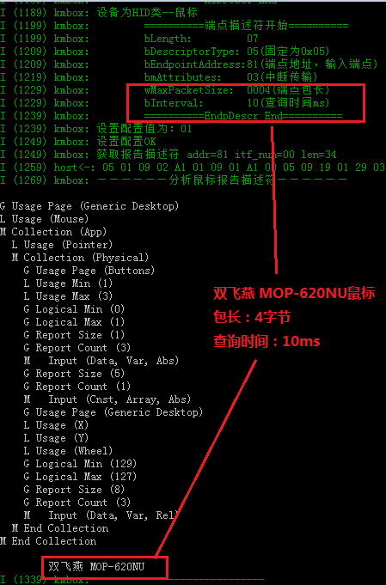

All right, you're not blowing hot air.The train is not pushed.Let's start today's Kmbox mouse macro function.Make sure you read through these functions to know what they do.This will give you an idea of what to program.Let's go from top to bottom one by one.

## **Left The left mouse button controls the function**

The left function is used by software to control the left mouse button.The left mouse button has two states, pressed and unpressed.Define pressed to be 1 and pressed to be 0.The state of the left mouse button is queried when no parameter is given, and the return value is as follows:

0: pop-up

1: physical press down

2: Software press down

3: Physical software all pressed

When giving parameters is to set the state of the left mouse button:

0: sets the left mouse button up

1: Sets the left mouse button down

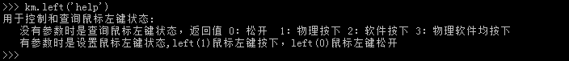

Note that if you want to detect if the left mouse button is down, attach the detected mouse to the Kmbox.Do you otherwise detect air?

## **Right mouse right control function**

The right function is used by software to control the right mouse button.The right mouse button has two states, pressed and pressed.Define pressed to be 1 and unpressed to be 0.No parameter is given to query the status of the right mouse button:

0: pop-up

1: physical press down

2: Software press down

3: Physical software all pressed

When giving parameters is to set the right mouse button state:

0: sets the right mouse button to click

1: Set the right mouse button to press down

Use as shown in the image below:

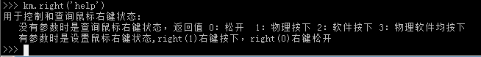

## **Middle mouse button control function**

The middle function is used by software to control the middle mouse button.The middle mouse button has two states, held down and up.Define press to be 1 and press to be 0.When no parameter is given is to query the status of the middle mouse button:

0: pop-up

1: physical press down

2: Software press down

3: Physical software all pressed

When given parameters is to set the state of the middle mouse button:

0: the middle mouse button is up

1: middle mouse button is pressed down

Use as shown in the image below:

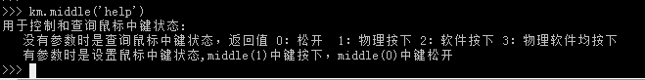

Ps: Many middle mouse keys are scroll wheels, which can be pressed.

## **Click the mouse button click function**

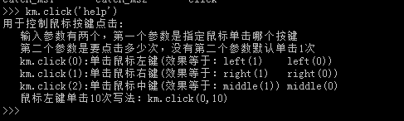The click function is used by software to control mouse key clicks, and which button to click is determined by the click parameters.

As shown in the image above: The first parameter is which key to click.The second parameter is the number of clicks.

Currently clicking the left button is 0, the middle button is 1, and the right button is 2. The click function packs Down and Up into one whole.Avoid writing scripts that are too low level analog.The second parameter is the number of clicks.If you want to double click.Then changing the second argument to 2 is a double click.And so on.Of course, you can also simulate clicks using Down and Up.Add a delay in between to control how long a single click holds down and how long it takes to lift.If you need to simulate human operation, try to use Down and Up to simulate.Click will be fast, too fast to be human-like.

## **Wheel mouse wheel control function**

The wheel function is used to control the mouse wheel.The wheel can be moved up and down, and the input parameter is the wheel roll unit value, which is positive for up movement and negative for down movement.For example, move 10 units up the scroll wheel.And move down 10 units screenshot below:

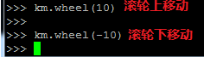

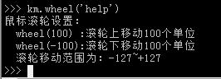

## **Side1, Side2, Side3, Side4, Side5 Mouse side keys control functions**

These functions are Kunming.Used to control the state of the side keys of the mouse.Input parameters are optional.No parameter is to query side key status:

0: side key up

1: Side key physically pressed down

2: Side key software press down

3: Side key physical software all pressed down

There are parameters to set the side key state:

0: is the side key up

1: The side key is pressed down

Use the screenshot below:

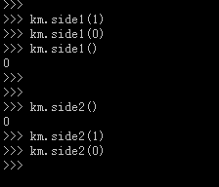

Ps: Side1 and Side2 are generally page-turning functions, even if your mouse doesn't have a side button.You have Kmbox.

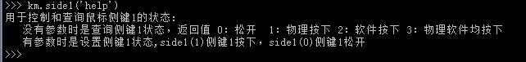

## **Move mouse movement control function**

Move is used to control the relative movement of the mouse, and the input parameters (x,y) are numeric types.The range is -32767 to +32767.And specify that x to the right is positive and to the left is negative.When Y goes down, it's positive and when Y goes up, it's negative.For example to move the mouse 10 units to the right and down, write:

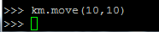

You will see that the mouse automatically follows this direction.A move is a relative move.At any time, the current coordinate point is used as the reference.Move x and Y units relative to each other.To pinpoint the move, use the moveto function in the back.

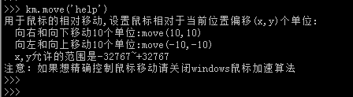

This is the basic use of the move function. If the move function is given only two parameters, the mouse movement will be completed in 1ms.There is no intermediate process.The actual effect is to step from the current point to the corresponding offset point.This is the most efficient and fastest.If you want to simulate human movement, you can use a move function with a parameter that constrains how many lines you want to fit from start to finish.Common sense tells us that the higher the number of the third parameter, the smoother the fitted curve will be, as shown in the figure below: use 1 straight line, 3 straight lines, and 1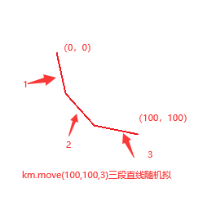0 straight lines fit the movement from (0, 0) to (100,100).

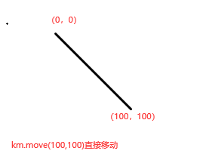

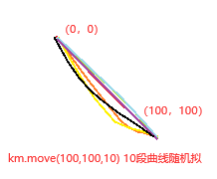

Above is the mouse track.You can see that the larger the number of fit points, the smoother the transition curve from start to finish.So.If you want to control the mouse simulation of human operation, you can add a third parameter to move.You can change the step state into a continuous state.

In addition, you will notice that each call to move(100,100,10) will result in a different mouse trajectory.Because there are an infinite number of curves past two points, the internal Kmbox will automatically pick up random points.Ensure smooth starting point to end point.

If you don't want Kmbox to automatically pick points at random, but want to actually control the intermediate curve, add two more parameters to the move function for reference approximation.

Km. Move (100100,10,50,60)

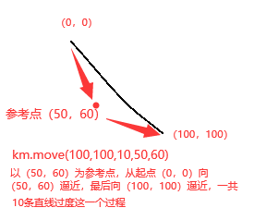

Where (50,60) is the reference point coordinates.The Kmbox will automatically fit the starting point to the ending point according to the reference point.Given a reference point, the trajectory of the Kmbox is uniquely determined.The direction of the curve and the degree of distortion are determined by the reference point.

## **Lock_mx mouse X direction masking function**

The Lock_mx(Lock Mouse X) function is used to mask the physical input in the X-direction of the mouse, and is mostly used to ensure that the X-direction movement of the software is not affected by the physical movement of the mouse.

The input parameter 1 is used to lock the X-axis direction:

When the X-axis is locked, moving the mouse left and right will not work, only up and down.

When the input parameter is 0, it will unlock the X-axis lock.

When there is no input parameter, the lock status of the X-axis is queried.

Return value 0: the mouse x axis is unlocked

Return value 1: Mouse X-axis is locked

A screenshot of its usage is shown below:

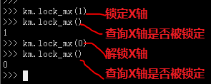

After locking the X-axis, the physical movement of the mouse does not affect the movement in the script.Make sure the script logic is not broken.Remember to use locks and unlocks together.Otherwise you get the idea!

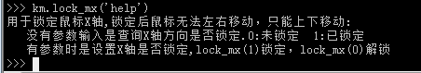

## **Lock_my mouse Y direction masking function**

The Lock_my(lock mouse Y) function is used to mask the physical input in the y-direction of the mouse, mostly to ensure that the software's Y-direction movement is not affected by the physical movement of the mouse.

The input parameter 1 is used to lock the Y direction:

When the Y axis is locked, moving the mouse up and down will not work, only move left and right.

When the input parameter is 0, it will unlock the Y-axis lock.

When there is no input parameter, the lock status of the Y-axis is queried.

Return value 0: the mouse x axis is unlocked

Return value 1: Mouse X-axis is locked

With the previous lock_MX.Try Lock_my for yourself.

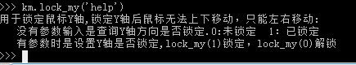

## **Lock_ml left mouse button mask function**

The Lock_ml(Lock Mouse Left) function is used to mask the physical input of the left mouse button, mostly to ensure that the software left button control is not affected by the physical left mouse button.

An input parameter of 1 locks the left mouse button:

When the left mouse button is locked, it doesn't matter how you physically click the mouse button.

When the input parameter is 0, the left mouse button is unlocked.

No input parameter is to query the lock status of the left mouse button.

Return value 0: The left mouse button is unlocked

Return value 1: The left mouse button is locked

Remember to lock and unlock the mouse.Otherwise you get the idea!

After noticing lock_ml, you can call catch_ml() to catch the left mouse button down and up, see Usage of catch_ml for details.

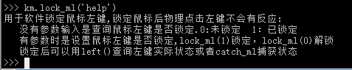

## **Lock_mm middle mouse button masking function**

The Lock_mm(Lock Mouse Middle) function is used to mask the physical input of the middle mouse key, and is mostly used to ensure that the software middle key control is not affected by the physical middle mouse key.

If the input parameter is 1, it locks the middle mouse key:

When the middle mouse button is locked, it doesn't matter how you physically click the mouse button.

An input parameter of 0 will unlock the middle mouse button.

When there is no input parameter, it is the locked state of the key in the query.

Return value 0: The middle mouse key is unlocked

Return value 1: Middle mouse button locked

Remember to lock and unlock the mouse.Otherwise you get the idea!

After noticing lock_mm, you can call catch_mm() to catch middle mouse button presses and lifts, see Usage of catch_mm for details.

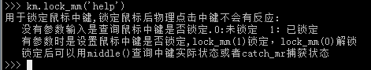

## **Lock_mr Right mouse button masking function**

The Lock_mr(Lock Mouse Right) function is used to mask the physical input of the right mouse button, mostly to ensure that the software right mouse control is not affected by the physical right mouse button.

When the input parameter is 1, it locks the right mouse button:

When the right mouse button is locked, it doesn't matter how you physically click the mouse button.

When the input parameter is 0, the right mouse button is unlocked.

No input parameter is to query the lock status of the right mouse button.

Return value 0: The right mouse button is not locked

Return value 1: Right mouse button locked

Remember to lock and unlock together.Otherwise you get the idea!

After noticing LOCK_MR, you can call CATCH_MR to catch the right mouse button press and lift, see Usage of CATCH_MR for details.

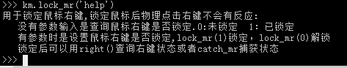

## **Lock_ms1 Mouse side key 1 Mask the function**

The Lock_ms1(Lock Mouse Side 1) function is used to mask the physical input of the mouse side key 1 and is mostly used to ensure that the software side key 1 control is not affected by the physical mouse side key 1.

The input parameter 1 is used to lock the mouse side key:

When the side mouse button is locked, it doesn't matter how you physically click the mouse.

An input parameter of 0 will unlock the side mouse button.

If there is no input parameter, it is to query the lock status of the side key.

Return value 0: The mouse side key is unlocked

Return value 1: The side mouse button is locked

Remember to lock and unlock the mouse.Otherwise you get the idea!

After noticing lock_ms1, you can call CATCH_ms1 to catch the right mouse button press and lift, see Usage of CATCH_ms1 for details.

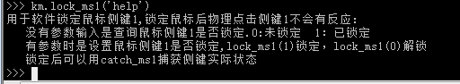

## **Lock_ms2 Mouse side key 2 Mask the function**

The Lock_ms2(Lock Mouse Side 2) function is used to mask the physical input of the mouse side key 2 and is mostly used to ensure that the software side key 2 control is not affected by the physical mouse side key 2.

The input parameter 1 is used to lock the mouse side key:

When the side mouse button is locked, it doesn't matter how you physically click the mouse.

An input parameter of 0 will unlock the side mouse button.

If there is no input parameter, it is to query the lock status of the side key.

Return value 0: The mouse side key is unlocked

Return value 1: The side mouse button is locked

Remember to lock and unlock the mouse.Otherwise you get the idea!

After noticing lock_MS2, you can call CATCH_MS2 to catch the right mouse button press and lift, see Usage of CATCH_MS2 for details.

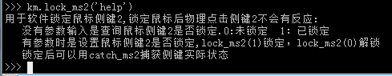

## **Screen mouse precisely controls the range limiting function**

As we saw earlier, all mouse data received on the computer is forwarded by Kmbox to the PC.In principle, Kmbox knows how much the mouse has moved in X and Y directions.If we could record the current x and y, wouldn't we know where the mouse is on the screen?In principle, it makes sense.The coordinate statistics inside Kmbox are also based on this idea.However, there are some exceptions.Such as:

When you move the mouse to the top left corner of the screen, then you continue to move to the top left corner.The mouse pointer does not move.

Because Window thinks your mouse is already at his boundary.It can't get any smaller.But the code underneath the mouse is still there.Move left, move up.But the reality is that the mouse doesn't move.If you're still counting low-level data at this point, something is definitely wrong.To solve this problem.Let's introduce a mouse range limiting function Screen.This function corresponds to the maximum range our mouse can move.For example, our monitor resolution is 1920X1200.So we can restrict the dead mouse to only move within this range.Any movement outside this range does not count.This will allow for a one-to-one correspondence between the screen coordinates and the Kmbox coordinates.

First, call screen without the arguments and find that the return value is (0,0).That is, there is no restriction on the screen size.

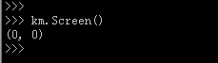

Now let's limit how far the mouse can move according to the actual situation:

My monitor is 1920x1200. So just set the allowable movement range to Screen(1920,1200).

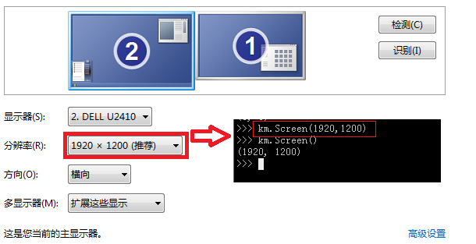

The KmBox inside limits how far the mouse can move.But it doesn't work at this point.Because KmBox didn't know where the mouse was on the screen.Did it cross the line.Next you need to call a calibration function zero.

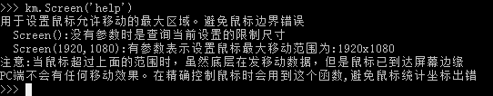

## **The Zero mouse precisely controls the zeroing function**

The Zero function will make the mouse automatically calibrate.That is, the mouse moves to the upper left corner of the screen (0,0), and the current mouse coordinate point is recorded in real time.It can be used to accurately control the movement of the mouse on the screen.It also automatically drops packets when the mouse exceeds X,Y defined by Screen (because the mouse does not move at the boundary even when the underlying data is sent).It should be noted that the mouse acceleration algorithm of Windows should be removed.Otherwise, the mouse will not move according to the actual data of the underlying mouse.In order to improve the speed of the mouse, Windows uses a certain acceleration algorithm, which will predict the target position according to the acceleration of the mouse packet.We in order to precise control.We need to turn this feature off.Otherwise it will also show an error.Remove the mouse acceleration algorithm as follows.

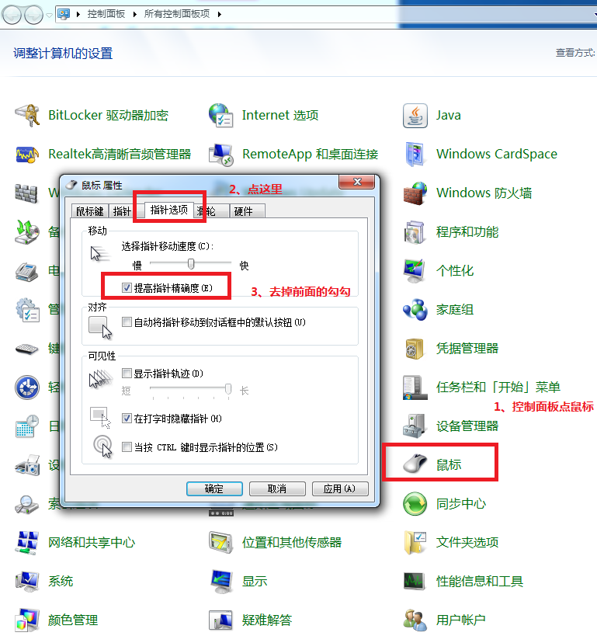

The Zero function can be used as follows:

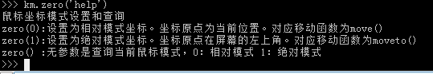

## **Getpos mouse precise control to get the current position function**

The Getpos function is to get the physical location of the current mouse.This is the coordinates of the internal statistics of KmBox.This function only makes sense after Zero is called.It implements a one-to-one correspondence between the kmbox coordinates and the screen coordinates.In theory, pick any point on the screen.Move the mouse however you want.The physical coordinates at this point are constant.The return value of Getpos is the physical coordinates of the current point of the mouse.The first element is the x-coordinate, and the second element is the Y-coordinate.

Here's the screenshot:

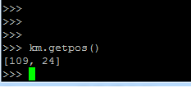

## **Moveto mouse precise movement function**

Moveto is moving the mouse to absolute physical coordinates (x, Y).So this function is also available after the zero function is executed.Unlike the move function, the origin of moveto's coordinates is at the top left corner of the screen (0,0).For the move function, the origin of the coordinates is the current mouse position.Moveto can quickly and accurately move the mouse to the specified position.

This function can be used as follows:

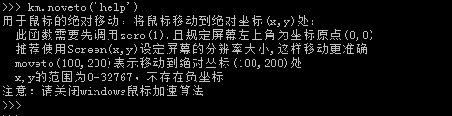

Note that this function is normally used with getpos.Say you want to move to a certain coordinate point.The coordinates of this point can be obtained through getpo.Then call moveto to move exactly to the point.

This is the basic use of the moveto function. If only two parameters are given to the moveto function, the mouse movement will be completed in 1ms.There is no intermediate process.The actual effect is to step from the current point to the corresponding target point.This is the most efficient and fastest.If you need to simulate artificial trajectory movement, you can use a moveto function with a parameter that constrains how many lines you can expect to fit from start to finish.It is common sense that the higher the number of the third parameter, the smoother the curve will be fitted, as shown below: one straight line, three straight lines, and ten straight lines are used to fit the movement from (0,0) to (100,100).



* 

The figure above shows the mouse track.You can see that the larger the number of fit points, the smoother the transition curve from start to finish.So.If you want to control the mouse simulation of human operation, you can add a third parameter to move.You can change the step state into a continuous state.

In addition, you will notice that each call to move(100,100,10) will result in a different mouse trajectory.Because there are an infinite number of curves past two points, the internal Kmbox will automatically pick up random points.Ensure smooth starting point to end point.

If you don't want the Kmbox to automatically pick points at random, but want to actually control the intermediate process curve, add two more parameters to the moveto function for reference approximation.

Km. Moveto (100100,10,50,60)



Where (50,60) are the reference point coordinates.The Kmbox will automatically fit the starting point to the ending point according to the reference point.Given a reference point, the trajectory of the Kmbox is uniquely determined.The direction of the curve and the degree of distortion are determined by the reference point.

## **Catch_ml left mouse button capture function**

The catch_ml(catch mouse left) function is used to capture the physical input of the left mouse button, mostly in cases where special handling of the left button is required.It is used in the same way as catch_kb for a keyboard.Below is how catch_ml is used

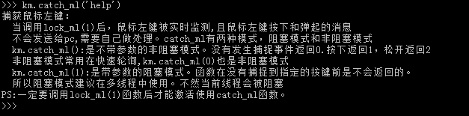

## **Catch_mm middle mouse button capture function**

The CATCH_mm (catch mouse Middle) function is used to capture the physical input of the middle mouse key, mostly in cases where special handling of the middle key is required.It is used in the same way as catch_kb on a keyboard.Below is how catch_mm is used

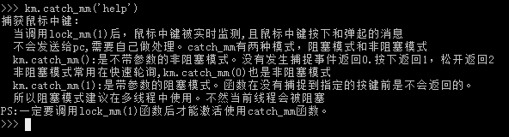

## **Catch_mr right mouse button capture function**

The catch_mr(catch mouse right) function captures the physical input of the right mouse button. This function is used when the right button needs special processing.It is used in the same way as catch_kb on a keyboard.Below is how catch_mr is used

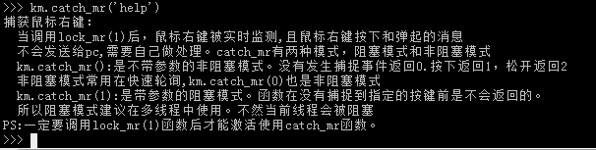

## **Catch_ms1 Mouse side key 1 Capture function**

The CATCH_MS1 (Catch mouse side 1) function is used to capture the physical input of the mouse side key 1, mostly in cases where special handling of the side key 1 is required.It is used in the same way as catch_kb on a keyboard.Below is how catch_ms1 is used

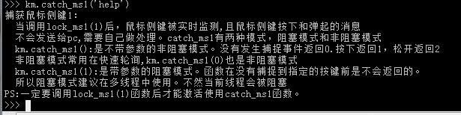

## **Catch_ms2 Mouse side key 2 Capture function**

The CATCH_MS1 (Catch mouse side 2) function is used to capture the physical input of the mouse side key 2, and is mostly used when special handling of the side key 2 is required.It is used in the same way as catch_kb on a keyboard.Below is how catch_ms2 is used

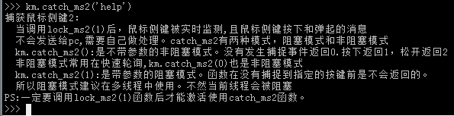

These are the functions currently supported by mouse macros.If you have any new requirements or comments, please feel free to contact me.

# **Other functions and modules**

In the previous sections.You should already have a grasp of what functions KmBox's keyboard and mouse macros include.This section covers the other functions.They may be used.

## **Debug Debug function**

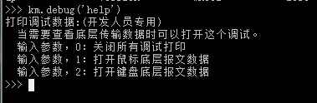

## **Delay delay function**

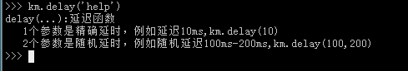

## **Reboot Development board restart function**

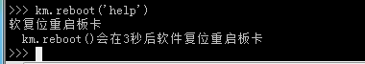

## **Version Version query function**

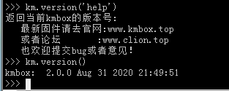

## **Rgb_free Releases the GPIO of the three-color LED**

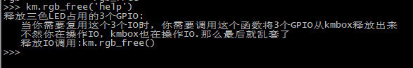

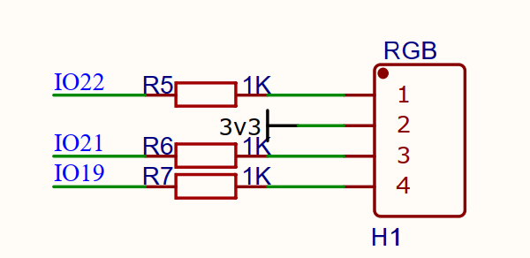

The RGB pin controls the IO as shown in the image above.

## **Mode Mode switch function**

Kmbox has a total of 7 transmission modes, namely USB mode, Bluetooth mode, KVM mode.In multiple hosts, you can use this function to switch between different working modes.

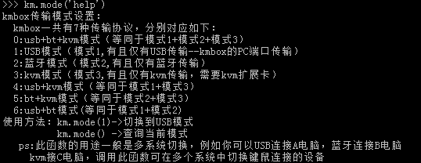

## **RNG random number generation function**

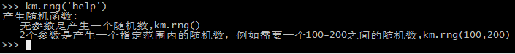

## **Freq keyboard and mouse report frequency overclocking setting function**

The km.freq() function is used to force the reporting frequency of the keyboard and mouse.This is not required by default.The default value is

200, that is, the keyboard and mouse upload 200 this report every second.If the parameter is not given to query the current report frequency, the parameter is given to forcibly set the report frequency. The value range is [100,1000]. The report frequency is an inherent attribute of USB devices.If overclocking is forced, it may bring instability to the device.Regular keyboards and mice report at 125Hz. You can force the frequency to increase if your mouse is too slow.See the km.freq('help') function for instructions on how to use freq.

## **The user keys**

There is a micro switch on the Kmbox.This switch does two things:

One: When upgrading firmware, you can hold down this key if there is no automatic download.(Generally not needed)

Two: When the program runs normally, the behavior of this key is completely determined by the user's own script.The key corresponds to IO0.It is low when pressed.For basic IO operations refer to this script:

## **MAC gets machine code functions**

The machine code is the board ID card, and the machine code of each board is unique.Machine codes are mostly used for script binding machines.Implement the registration authorization function to prevent scripts from being used on unauthorized devices.What encryption algorithm is defined by the script author himself.

The return value of a MAC function is a set of six elements.The return value is different for each board.

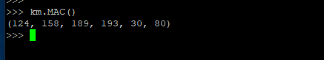

The above are the API functions provided by the KM module.The KM module should be basically sufficient for keyboard and mouse operation.But our KMbox is not just a keyboard and mouse operation so simple.The keyboard and mouse are only part of the function.Kmbox also has many modules!You can see which modules the board contains by default by typing help(' modules') :

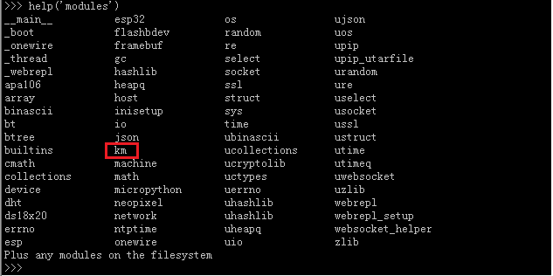

Where KM is just one of many modules.I can't talk about each module and function one by one.With the previous KM module learning.The same goes for the other modules.Find out for yourself here.You can use KmBox to drive hardware or you can use it to write software algorithms.DIY all kinds of electronics are very suitable.

# **Kmbox practical article**

In the previous sections, it's easy to use putty to try out how to use each function, but this is still a little far from the actual script.In this chapter, you'll learn how to write scripts that string together the previous apis.The transition from theory to practice.

Script writing is actually very simple, is the previous API call and combination, plus condition judgment, loop and so on.These are based on the function you want to achieve to determine.As you can see from the previous section, Python interprets online.When you finish typing the code, it executes it immediately.If the code is hundreds or thousands of lines, writing it in putty may drive you crazy.This section introduces a new tool, upycraft.exe.

It is a specialized code editor and downloader.He can also be used for debugging.This gadget is ten megabytes and will satisfy 90% of your development efforts.Double click on UpyCraft. The app screen will appear.

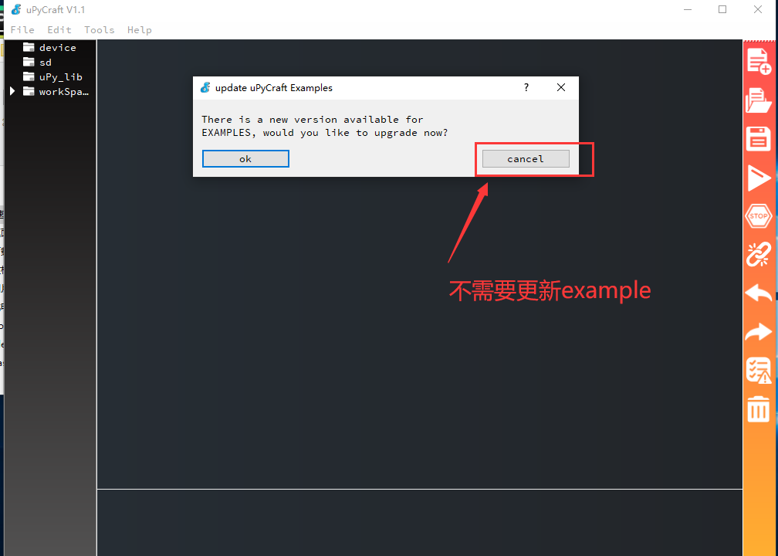

When it opens, you need to connect the development board: Tools --> Serial -->COMxx to connect to the development board

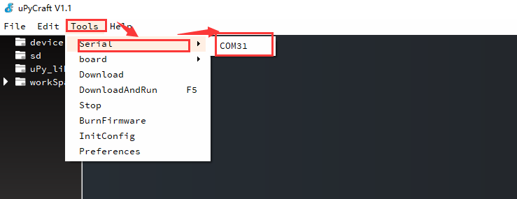

If the connection fails, check the serial driver.It looks like this after the connection.This is really just a console for putty.

## **Read the script inside the Kmbox**

Click File -->Reflush Directory in turn to read the script inside the Kmbox (MPY script cannot read)

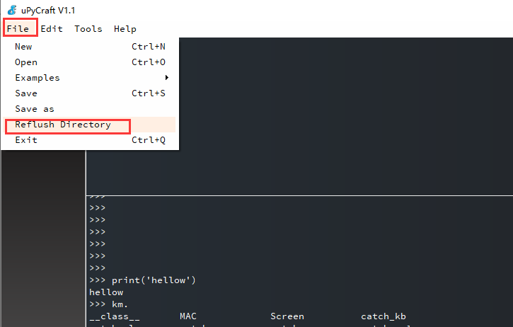

You can see the script files inside the board in the Device folder. Double-click the corresponding file to view the contents.

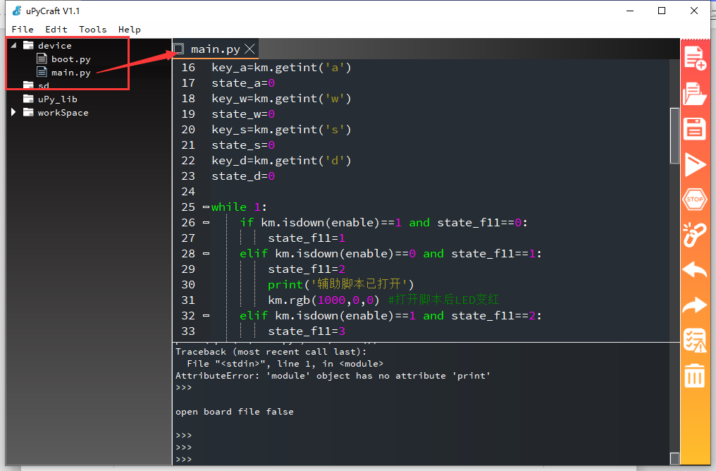

Modify, save and rename the script file.

## **New Script 3**

File -->New to create a New document (Ctrl+N is the shortcut). The newly created file does not have a name. Press CTRL + S to save the file and marry it a name. Click OK. At this point, you can write the script functions you need into this file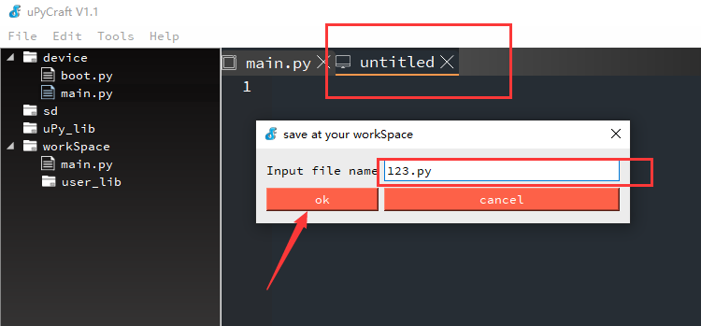.

## **Debugging scripts**

For example, write a simple script in 123.py.Print Hellow every 1 second.

Debugging this script is simple.There are several ways to debug it:

A:

Run in memory (recommended) by pressing CTRL + E on the console below.Kmbox will go into copy mode.

Copy the contents of the 123.py file directly (CTRL + C), then right-click on the console and paste (don't use the shortcut CTRL + V). After pasting, press CTRL + D in the console. Then the code you just copied will run inside KmBox.

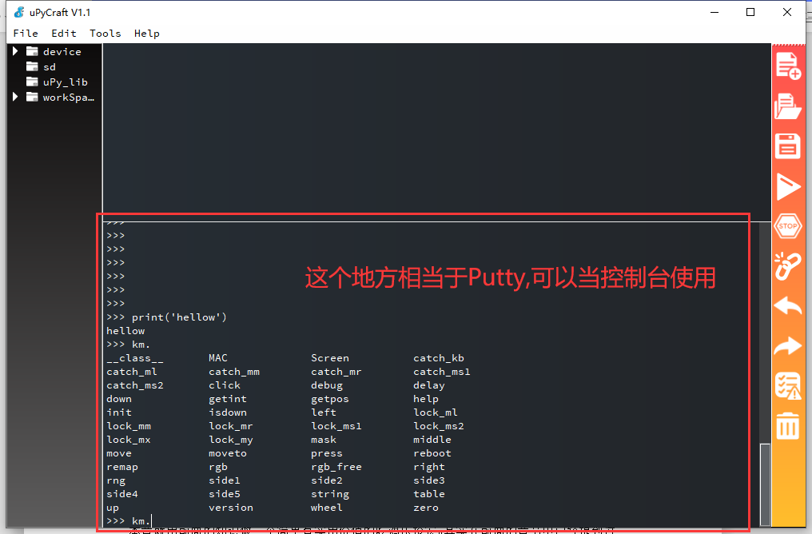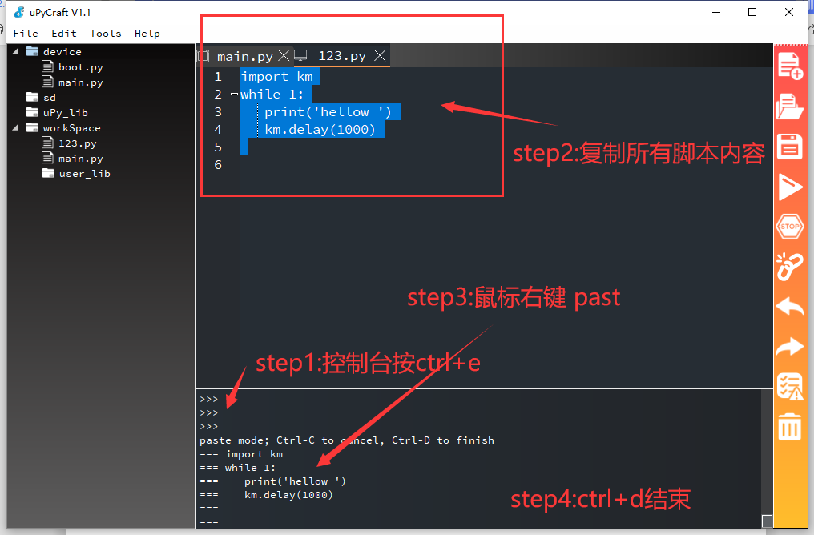

After Ctrl+ D, the script will already be running.As shown in the image below.

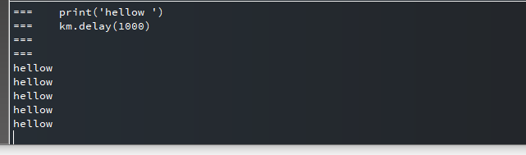

If you need to end the run, press CTRL + C at the console.

Method 2:

Click directly on the RUN on the right. This method is not recommended.This will be downloaded to the board.Flash has a write life.Usually 100,000 times won't work.It is recommended to use method 1, the script is OK and then burn it to the inside of the board card.

## **Burn write scripts**

If there are no problems with the debug script and we want to save the script permanently, we need to burn the script to the development board.

For example, the previous 123.py needs to be burned to the development board after confirming that the function is correct.Click 123.py-- >Tools----->Download to burn to the development board

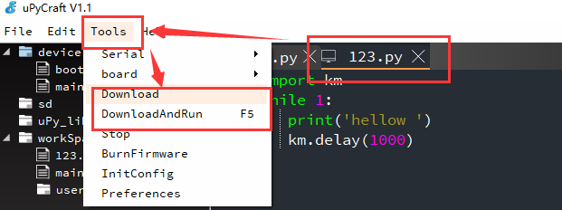

DownloadAndRun is to run the script immediately after downloading it.If you don't need to run it, just download it.

Burn scripts do not support MPY files.See: Users Using Encrypted Files for Mpy burn scripts

## **The simple application of mouse macro (eat chicken pressure gun macro production)**

This chapter will use the previous knowledge to make a simple and practical value of eating chicken press gun macro.In fact, it has been mentioned in the previous chapter how to achieve the pressure gun.The basic idea is to press the left button, the mouse automatically moves down to achieve.

But you have to ask me how much to move down?I'm sorry to tell you that I don't know.The only people who know the estimate of this parameter are programmers who write chicken-eating apes.But we can test it.Well, let's give Operation Wilderness a simple test run today.Hand in hand teach you how to use Kmbox to write a chicken pressure gun plug-in.

See this video for detailed steps:

<https://www.bilibili.com/video/BV1Ya4y1Y7ku/>

Please go to download the flock script file.

# **How do I use third-party libraries**

In the basic tutorial above you can already test and validate simple logic code in the Repl environment.But real projects may require many PY files, all of which are interdependent.How do you call other libraries or modules from inside KmBox?

## **The default module**

Come on, start cracking this problem.As the saying goes, knowing your enemy won't end in a hundred battles.To introduce other modules, first look at which modules you already include. You can see which modules are currently included by default in KmBox by entering the following command in the REPL interface:

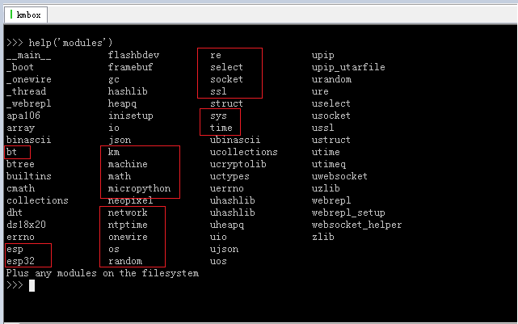

From the above we can see the commonly used KM module, SYS module, Time module, Machine module, OS module and so on...

In other words, the above module names can be directly included in our script using import XXXX.This is what the script looks like:

By default, only GC (garbage management) module, KM (keyboard and mouse control) module, UOS (file system management) module, and BDEV (file management) module are loaded.After you press TAB, the screenshot is as follows:

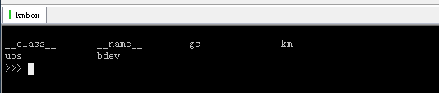

If if you want to use the Machine (Hardware Control) module.You can just use "Import Machine" and press TAB to see that the Machine module is already packed into our environment.

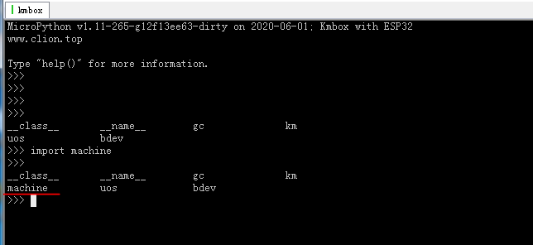

The Machine module contains some hardware operations, such as ADC, DAC, PWM, I2C, GPIO and so on.

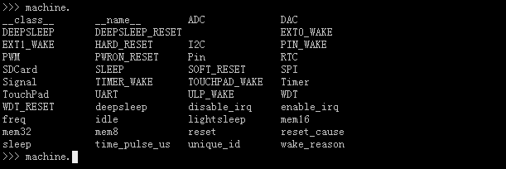

Then comes the problem.If you do introduce something that is not in the default library.Is Kmbox not going to cut it?

No and no!There are several ways to introduce other Modules.Today, let's do a project that replicates it a little bit.Kmbox automatically draws a five-pointed star.Before writing a script, first think about how to draw a pentacle with a mouse.

Here are some ideas:

Pupil composition, look at the picture to talk:

Step 1: At an Angle of 72° to the X-axis, draw a line segment of length L.

Step 2: Deflect it 144° to the right and draw a line segment of length L.

Step 3: Deflect 144° to the right and draw a line segment of length L.

Step 4: Deflect 144° to the right and draw a line segment of length L.

Step 5: Deflect 144° to the right and draw a line segment of length L.

After the above 5 steps, you have a five-pointed star.484 Easy?So how do you do that with mouse macros.Please look directly at the following code:

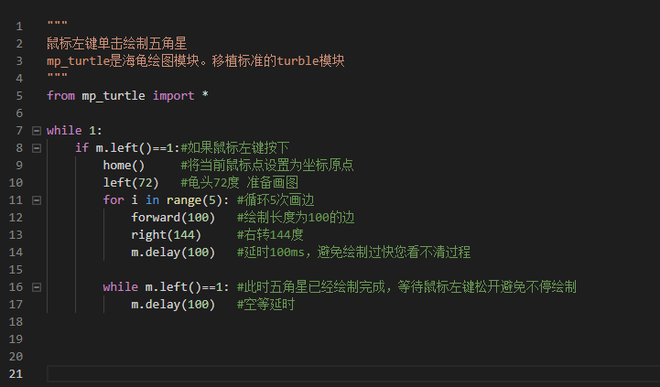

Press the left mouse button in the image above, set the current coordinates to the origin, and then offset to the left by 72 degrees.Draw a line of length 100 five times in the for loop, deflecting.You have the pentagram.

The actual running effect of the script video is as follows: Click me to watch video

Click Me Watch Video Click Me Watch video

You may be wondering, what is home?What is Left?The forward is what?What is right?I don't think Km has any of these functions either??Right!Not really.The functions not seen above are defined in the mp_turtle module.Mp_turtle in turn calls the KM module.The KM module is repackaged.Today's lesson will focus on learning how to use multiple script files.

## **How files are stored (Entry level)**

In layman's terms, file storage is to save the source code of the module you want to introduce into KmBox.You can then import the module directly.So how do I save the py file inside the Kmbox?You can use the following tools.

1. Upycraft

Upycraft This is a compact code editor and debugger designed specifically for use with MicroPython.Please go to Group Sharing to download it.

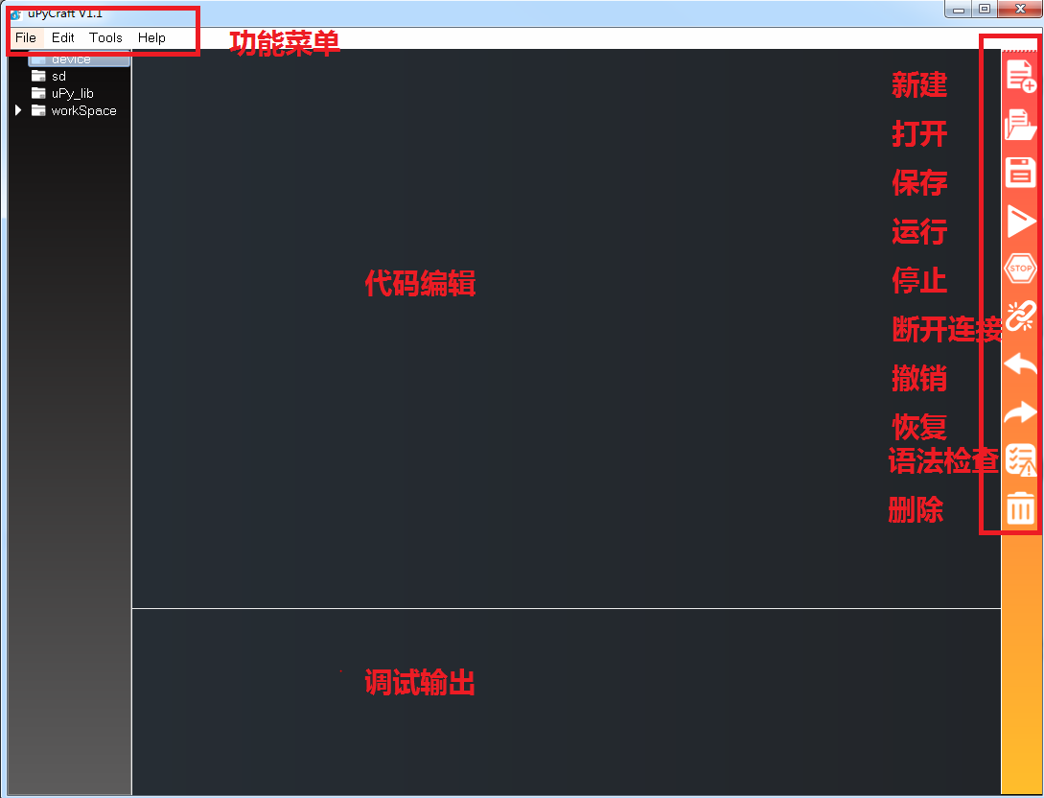

Let's take KmBox as an example and introduce how to use it and how to transfer files.Open the software and select the board chip model ESP32 from the Board TAB under Tool menu. The diagram below:

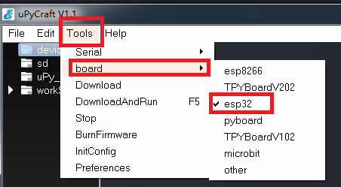

Then select the actual serial port number of KmBox.

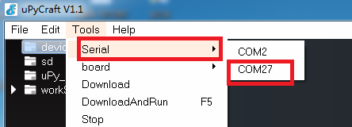

This will allow you to perform REPL operations in the debug window (just like putty).

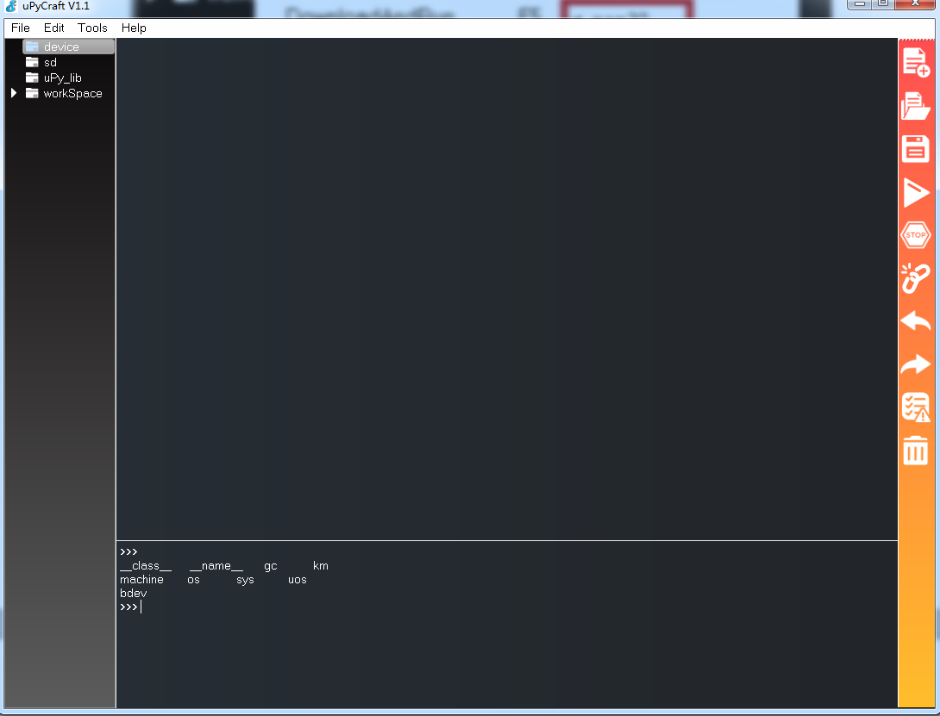

How do you import third-party files or modules?The following is an example.Let's say you find a module on the Internet that has a drawing function.

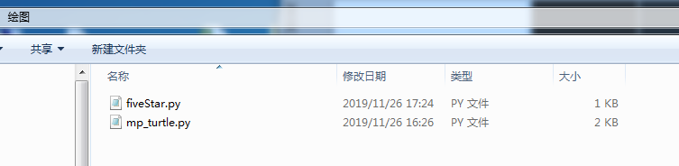

This drawing module includes two files.We open both files in turn.

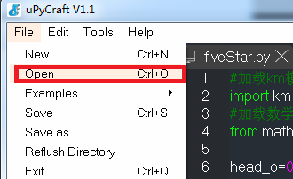

When opened, it will look like the following image:

Then download it to the development board.Tools - > Download.Note that download is downloading and only saves the file and does not run the file.DownloadAndRun below is to run the file after saving it.From the source code you can see that the fiveStar. Py file dependency is mp_turtle. Since the mp_turtle.py file is not already on the board, run it with certainty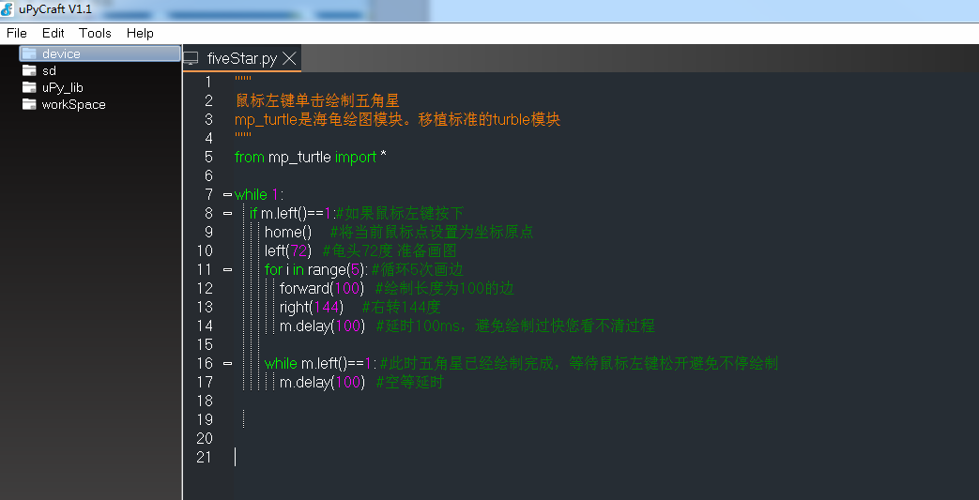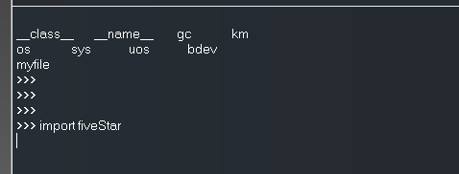Will go wrong.

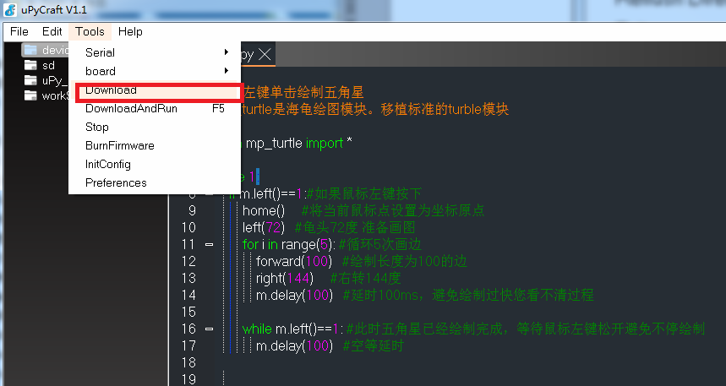

The following message will appear on the console after downloading.

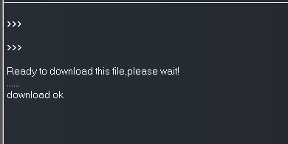

Similarly, open the mp_turtle.py file and burn it to the development board.

Ps: As you can see from the mp_turtle.py source file, the underlying dependencies are KM module and math module.These are the modules supported by the board.So all the dependencies of this script are satisfied.Then it must work.

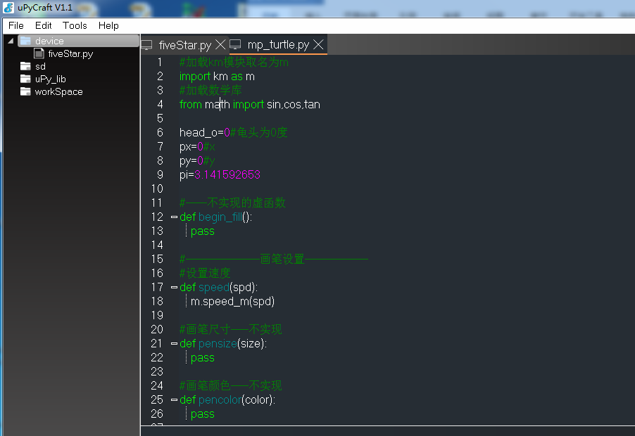

You'll see these two files on the left when you're done.You can also type os.listdir() from the console to see which files are mounted on the current file system.As you can see below:

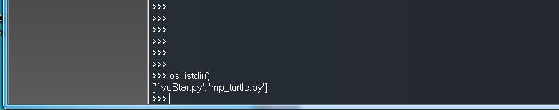

At this point these two files are already inside KmBox.You can call fiveStar. Py directly.

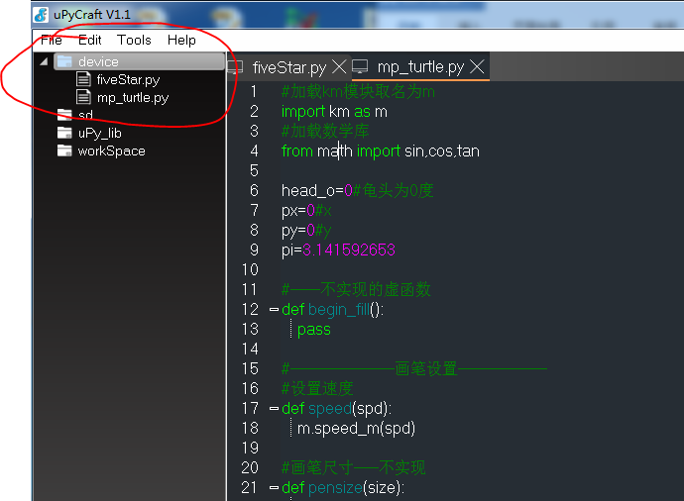

If you call help (' modules') at this point, will the two modules that were just passed in appear?The answer is no.You should know that help (' modules') shows modules compiled directly from the source code.The above file transfer method is a user defined module.It's just like Windows.A factory-installed app is the same as a user-installed app.

Use third-party modules that are passed in:

You can use this module by typing import fiveStar directly into the console.The diagram below:

How did it crash ？？？？？Nonono!!Not a crash.See the source code for Fivestar.py

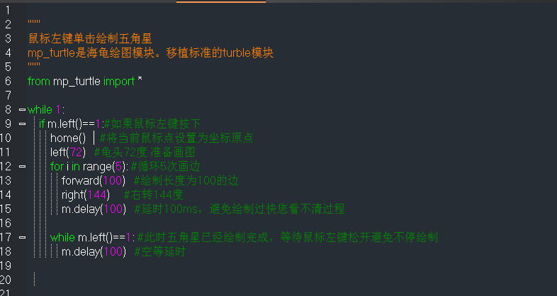

He is waiting for your left mouse button to press in while 1.Then draw the pentagram.Remember, your mouse needs to be plugged into the Kmbox for him to know if the mouse is down or not.If you plug it into the computer, the computer won't tell Kmbox that the mouse is down.

If you want to stop the script, press CTR + C directly from the console.

After the interrupt you can continue using Import fiveStar and view the member functions inside.The following figure

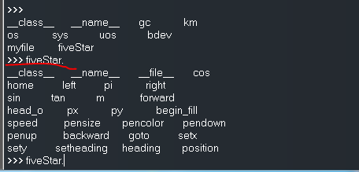

That is, as long as you have the source code, solve the dependency problem.Eventually, everything will run inside KmBox.Usually, the PY file burned to the board is already debugged.If you are in the development phase, it is recommended to run in memory.Only burn it inside the board when you need to release it.

# **Firmware upgrade (board brick fix)**

In the previous tutorial, you should have learned how to use scripts.How to extend scripts yourself.As the saying goes, you can't walk by a river without getting your shoes wet.So what if there is a problem with the script, it doesn't work properly, and the board doesn't listen to the instructions?

This chapter will teach you the most violent move of all, the brush.As the name suggests, it is equivalent to reinstalling the operating system.There are two ways to brush the Kmbox, after the brush must power off and restart the development board (insert and remove the USB1).

The first method requires tools: uPyCraft(the little editor from before), open Tools ->BurnFirmware

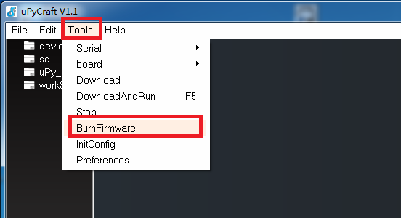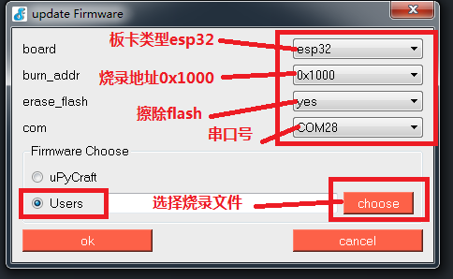

You will see this interface:

You'll see. Go to Choose and select the firmware for KmBox.Click OK.

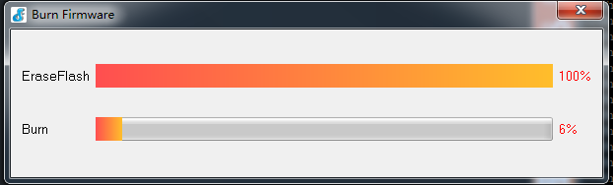

Wait for both progress bars to run their course.

Plug and unplug the development board.Repeat the serial port and the board will be restored to its original state.Mom doesn't have to worry about programming board bricks anymore.

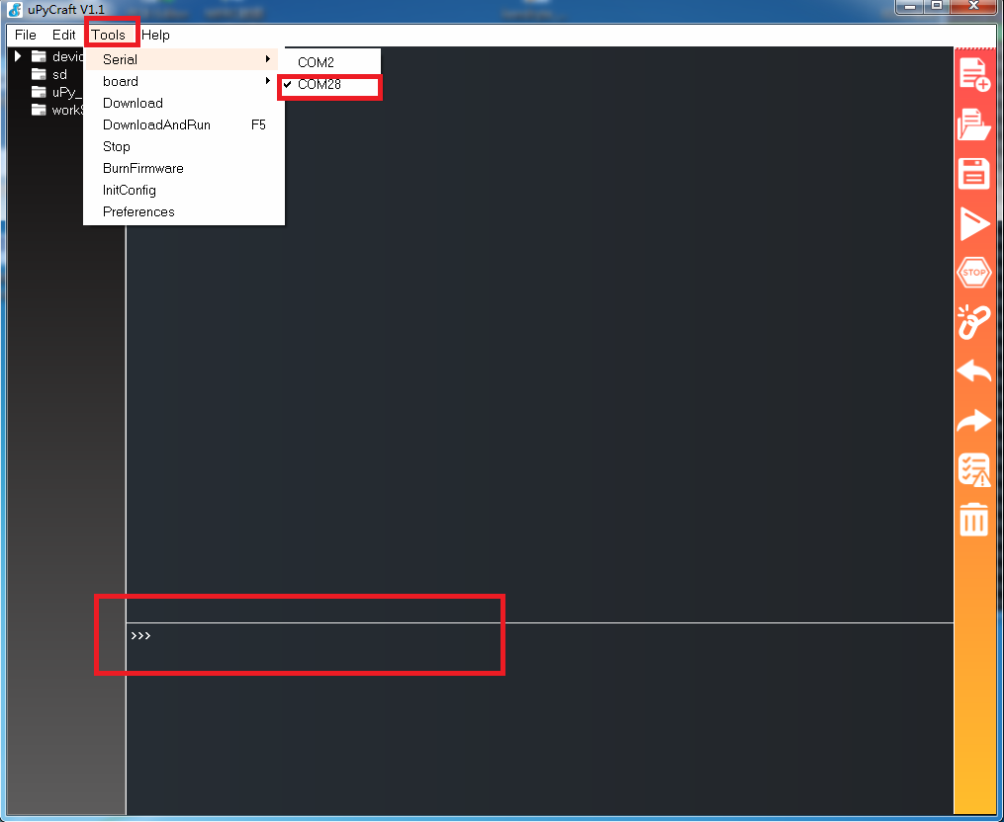

That's enough for 90% of applications.

The second method is flash_download_tool_V3.8.5. exe, which is the download tool from Lexin's official website.It can be used for mass production and can also change the RF characteristics of WIFI and Bluetooth.If you have several apps, you can use the official burning tool.It's much faster than the one above.It's up to you to find out how to use it.Anyway, the blind JB toss board will not be a brick.

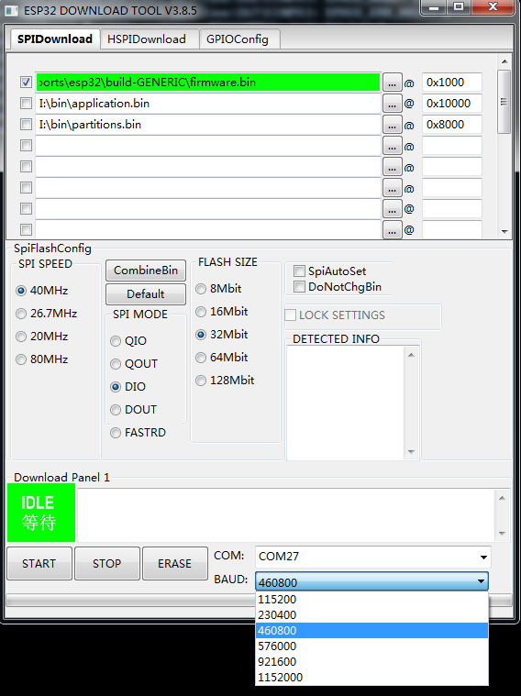

# **Kmbox Advanced tutorial**

## **How do I get a script to run automatically when powered on**

Many times with the script written, we want the script to be saved inside the Kmbox and the Kmbox will automatically run as soon as it is powered on.Instead of getting a console and typing instructions to invoke it.This is actually covered in the "How to Use third-party Libraries" section above.So exactly how to boot?For example: let the computer boot to run QQ.First you have to install QQ in the computer, and then set QQ to boot.Similarly, if you want your script to run as soon as it starts up.In fact, the same as the operation on the computer, first download the script to Kmbox (equivalent to installing QQ), second set the script to boot.

In How to Use third-party Libraries, you know how to download scripts.There is only two steps left before boot-up: Set the script to boot-up.The boot process of Kmbox is fixed.It will first run the boot.py script.Then run the main.py script.Boot. py contains some initial configuration parameters of the system.It is like the BIOS after the computer is pressed to boot. It is mainly responsible for initializing the system environment.After the BIOS runs, it enters the system.Kmbox's system is the equivalent of main.py.

As shown, nothing is done inside boot.py.You can't see the main.py file either (because the script is not booted by default).So, run your script if you want it to boot up.It's as simple as changing the name of the script you want to run to main.py or boot.py.**It is recommended to use the name main.py.**Boot.py may be followed by other pre-configuration.

## **Single-threaded code optimization**

In the previous tutorial, we mostly used a large while True loop and then wrote the detection logic inside it.When the amount of logic is small and the execution time is small.Basically, you don't have to worry about efficiency.But sometimes you need to think about efficiency.Here's an example.Learn how to optimize a script.Make sure your execution is efficient.

For example: you need a script that automatically kills monsters, and the script needs to have two functions.

1. If you press the A key, you will automatically release the 5 skills 1, 2, 3, 4, 5
2. Call out automatically every 10 seconds.

It's easy to think of the "A" button as isdown, the "Press" button as press, and the "delay" button every 10 seconds.It's easy to write the code like this.

while True:

If km.isdown(' A '):# If A is pressed

Km.press ('1')# Drop 1 skill

Km.press ('2')# Lose 2 skills

Km.press ('3')# Lose 3 skills

Km.press ('4')# Lose 4 skills

Km.press ('5')# Lose 5 skills

Print (' I'm going to shout every 10 seconds ')

Km. delay(10000)# delay by 10 seconds

You can try the code above.Unsurprisingly, you'll see a print appear every 10 seconds.But if you press the "A" button, it's highly unlikely that 12345 will appear.As you can see below:

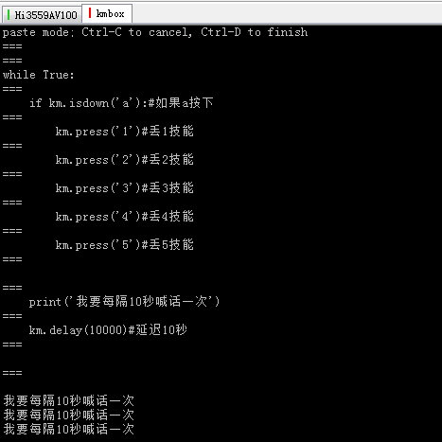

Why is this?The culprit is actually the km.delay(1000) instruction.Because the code runs line by line.Km. delay(10000) This instruction takes 10s from the time it starts running to the time it returns.During those 10 seconds, the CPU does nothing but wait for the 10 seconds to end before running the km.isdown(' a ') instruction.So Kmbox will only execute 12345 if you happen to press A while it is doing isdown(' a ').You'll find out.That's not what I need.I want to press A and he will immediately execute 12345.Let's talk about how to optimize the code.

As mentioned earlier, the main culprit is the delay function.It wastes CPU time.Causing a loop to take 10 seconds.If this delay is removed.You'll see that this main loop can go up to hundreds of thousands of times a second.This is equivalent to detecting ISDOWN hundreds of thousands of times per second.According to the Nyquist sampling theorem, the sampling frequency greater than 2 times can ensure that the sampling information is not lost.In other words.If the main loop runs 10,000 times a second.That means you can press 5000 times per second without losing data.The reality is that you can't press a button 50 times a second.So, in theory, as long as the main loop can execute 100 times per second you'll probably never lose a key.So make sure you don't lose the A key when you press it.We should increase the number of isDOWN calls as much as possible, so that it is more than 100.So here we introduce the first method, short polling.

Import time # is used for time statistics

Last_time =0 # Records the time of the shout

while True:

If km.isdown(' A '):# If A is pressed

Km.press ('1')# Drop 1 skill

Km.press ('2')# Lose 2 skills

Km.press ('3')# Lose 3 skills

Km.press ('4')# Lose 4 skills

Km.press ('5')# Lose 5 skills

if time.ticks_ms()-last_time>=10000:

Print (' I'm going to shout every 10 seconds ')

Last_time = time.ticks_ms()# Refresh the time of the last shoutout

#km.delay(10000)# Delay for 10 seconds

Comparing the previous code, the above code is tens of thousands of times more efficient.Good code is tens of thousands of times more efficient.This code doesn't waste CPU time.Use IF statements to quickly determine operations that are delayed by 10 seconds.Print when the time is up.The above code runs at least 10,000 times per second or more.There will be no failure to detect A press.So, in this case, you see that not only does it execute 12345 immediately when you press A, but it prints data every 10 seconds.But.There will still be problems with this code above.The problem is that it runs too fast.Things happen that you don't expect.Run this on the board yourself and you will see the result.

When you find the problem, you can figure out how to fix it.The code is written by people.If it runs too fast, find a way to make it not run so fast.Different people have different ways of implementing the same function.There is no best, as long as it meets the needs.

## **Multi-threaded Use**

Let's take the auto-kill script from the previous section as an example.How to use multi-threaded method to achieve.Let's go over the requirements again:

You need a script that automatically kills monsters. The script needs to have two functions.

One: If you press the A key, it will automatically release the 5 skills 1, 2, 3, 4, 5

Two: Automatic shout every 10 seconds.

Logically speaking, there is nothing between Shouting every 10 seconds and pressing "A" to press 12345.They can be viewed as two separate things.Can you write A function A that checks if A is pressed.A function B for him to shout automatically?Then the two functions "run at the same time".Would that be enough?Here is what we are going to talk about today, multi-threading.

When we talk about multithreading, hopefully you understand that even though logically A and B are running at the same time.But there is only one CPU.Any time A is running, B is not running (except for multi-core cpus).What you appear to be running at the same time is actually serial AB alternating.It's just that they alternate so fast that you can't feel it.Here's an example of multithreading:

' ' '

Kmbox supports multi-threaded operations as shown in the following example:

Those that need to be processed quickly are placed in thread A.

More time-consuming operations are placed in thread B.

A and B are logically independent.They run at the same time

' ' '

Import _thread # introduces multithreaded modules

Import Time # Introduce the time module

Keyval_a = km. Get int (' a ') # a

Km.mask (keyval_a,2) # masks Monitor A and joins the capture queue via catch_kb

#A thread -- quickly respond to tasks

Def thread_A () :

While 1: #A thread loops indefinitely

RetVal =km.catch_kb() # non-blocking capture of keystroke data

If retVal== keyval_A :# capture to 1 A press

Print (' a press...Execute the logic after A is pressed, such as the one-key N skill.')

#B threads - time-consuming tasks

Def thread_B(): #B thread function

While 1: #B thread loop indefinitely

Print ('B thread running...cputick=',time.ticks_ms())

Time.sleep (1.5) #1.5 seconds to sleep

_thread.start_new_thread(thread_A, ()) # Start thread A

_thread.start_new_thread(thread_B, ()) # Start the B thread

You can see that regardless of the latency in B, it does not affect the detection of A functions.A runs smoothly.I will post the above code into the Kmbox internal operation experience what is different.This is just a primer.The use of multithreading goes far beyond that.There's synchronization between threads, mutual exclusion, etc.You'll just have to explore for yourselves.

PS: The above code does not write thread exit, please improve yourself.The thread exit can refer to this: poke me to see the source code

## **Script encryption and authorization (there is technology to sell scripts)**

In the previous sections, our scripts were written in plaintext.So just get the py file.You can modify and use it without limit.But a lot of times, a script that you've worked so hard on doesn't want to be out in the open.Is there a way to encrypt the script and give the encrypted file to the user?This way you don't have to worry about source code leakage.And you can authorize users to charge by time or by number of times.What you charge is entirely up to you.Now for a simple example:

Let's say it's a one-shot deal.You implement a feature and you sell it to the user.Use password authentication.The user buys the key from you.If the key is correct, it is used, and if it is not, it is not used.For example, the plaintext source code is as follows (test.py) :

The import of km

IsAuthor=0 # Whether authorization is initialized to 0 -- Authorization conditions can be defined by yourself, such as key, machine code, time, etc.This is only a simple demonstration here

Def author (key) :

Global IsAuthor

If key=='123456': # Set the script key to 123456

IsAuthor=1 # Key correct allows allow the RUN function

Print (' Authorization code correct ')

The else:

Print (' Authorization code error!Please contact the script author: xxx@xx.com')

Def the run () :

If IsAuthor==0:# The key is incorrect

Print (' Sorry you are not authorized yet, please call Author to enter registration code ')

The return

While 1:

Print (' Script authorized and running...')

Km. The delay (1000).

Assume the script's key string 123456.The first function (author) is to authorize the use, setting the IsAuthor flag if the authorization is successful.When you run the run function, it checks to see if it has been authorized.It does not run without authorization.If we send the plaintext PY file directly to the user, I'm sure everyone knows how to crack it.So in order to protect the author's work, we need to encrypt it, using MPY-cross.The environment is Windows. As for the encryption method, you are free to play, anyway, after encryption, no one knows except the author himself.Script encryption is the author's job.The use of encrypted scripts is the user's job.Here's how to encrypt and use it from the perspective of the script writer and the user, respectively.

### **Script writers encrypt scripts**

#### **Method 1 of 3: Directly Drag and Drop Files That Need to be Encrypted (Recommended)**

I have compiled mpy_cross. Drag the script you want to encrypt directly onto MPy-cross.exe and release the left mouse button.The MPY file will be automatically generated in the folder where the exe is located:

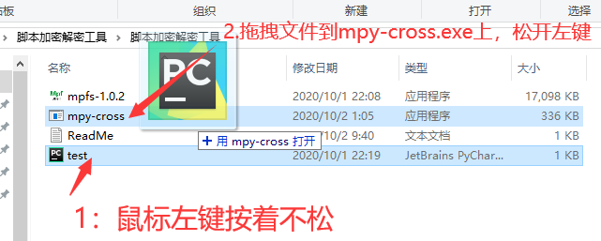

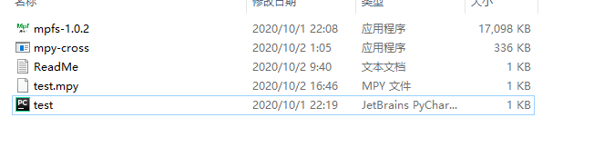

#### **Method 2 of 2: Compile MPY-Cross and generate it using commands under Python**

Step 1: The tool you need for encryption is MPyCross (Python environment built)-- note that the version number is 1.11. Other versions may not work.My Python version is 3.8.5



Install execute this command: PIP install mpy-cross==1.11

The installation process is as follows:

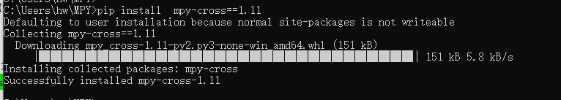

After the installation, we can convert the plaintext script PY into ciphertext MPY file.

Run the following command: python -m mpy_cross test.py ----- Test. py in yellow is the plaintext file to be converted.

The test.py file will automatically generate a test.mpy file after executing this command.The test.mpy file is the ciphertext file.This is the ciphertext file you can publish to your customers.You can compare the test.py and test.mpy files.

The test.mpy file is smaller and more efficient than test.py.And test.mpy is invisible.Don't worry about source leaks anymore.This is the end of the author encryption work.

**PS: Script encryption actually converts source code to machine code, so the volume of MPY file is smaller than the original file, and the execution efficiency is higher than PY file.**

### **Users use encrypted files**

Users use encrypted files (MPY) just as they use plain plaintext files (PY).You can think of MPY as equivalent to PY.The user just doesn't know the contents of the MPy file.To use an MPY file, you must first write it to Kmbox and then Import it to call functions.Upycraft can't transfer MPY files (because the authors didn't consider MPY files in the first place).Here's a new tool.Mpfs(go to the group download), its purpose is to download any type of file into the Kmbox.You can think of it as a downloader. Double-click it and run it as shown in the image below:

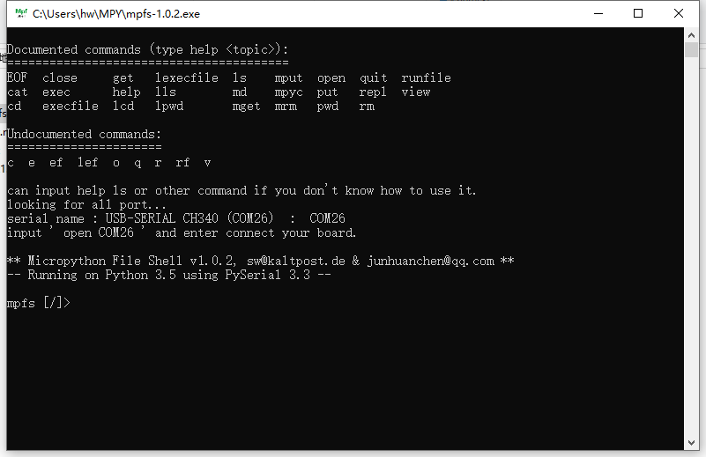

Using this software requires the board to be in REPL mode.If you don't know how to get into REPL mode, just swipe.The default is REPL mode.

Because MPY needs to be placed in the internal file system of the board.So you need to connect to Kmbox.

Type: Open COM26 -- Connect the development board (COM26 is the serial number)

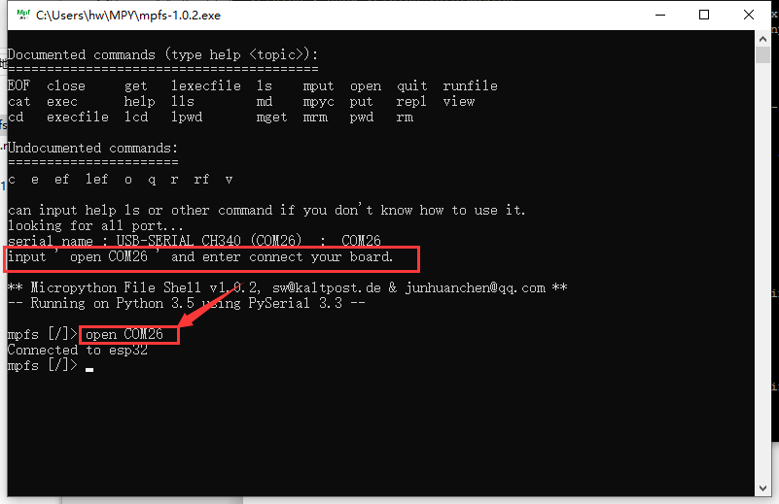

After the connection is completed, you can see that the connection is successful. Here, you can input commands such as LS MV as the internal operation in Linux..

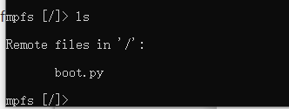

For example, after LS, you can see the boot. Py script in the current file system.Kmbox has a file system inside it.You can store all kinds of files.You can use OS libraries to create files, change file names, and so on.Now you need to write the MPY file to Kmbox's file system.

You only need to execute one instruction: put test.mpy

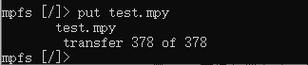

When executing this instruction, note that test.py and mpfs.exe need to be in their sibling directories:

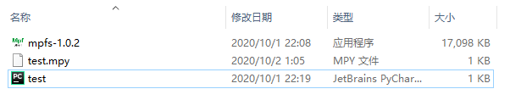

At this point the mpY file has been burned to the inside of kmbox.MPFS can be closed at this point.The next step is to run the encryption script.How to use it?Just like a normal py file.Just import test

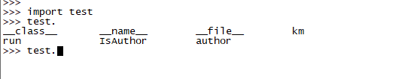

As you can see, all the functions written by the author are available here.You can call.From the source code on the author side, you must first call Author and pass in the key 123456 to use the run function.Let's try the following run first:

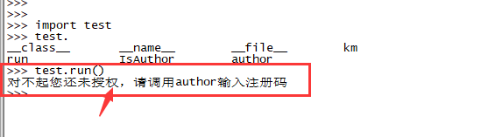

Next let's say I know the key is 123456 for a dollar from the author and call the following author(' 123456 ')

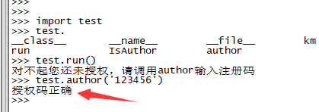

Once the key is correct, I can use the run function.

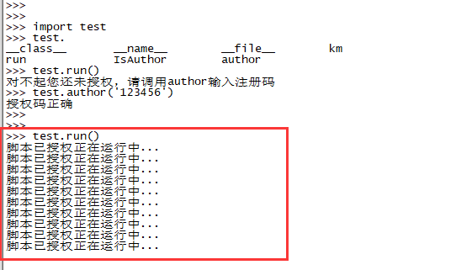

Of course, the above code is just a demonstration, isAuthor is directly given to the variable, should be wrapped into a class, set as a private variable.Encryption is not just a string.It can be bound using machine code.The key is different for each device.The rules are up to you.

## **Fire, burglar, and seal number**

### **Hardware prevent seal**

This chapter focuses on how to avoid hardware blocking.Although KMBox belongs to pure hardware physical plug-in, want to seal Kmbox said before unless do not let the keyboard and mouse.In the front you should know.USB devices are all available with VID and PID.If some games are already broken, the specified VID and PID devices are not allowed to play games.There's nothing you can do about it.After all, game companies have the right to do that.In those days, 360 and QQ fought against each other. I didn't have him on your computer, he didn't have me!But general game companies dare not do this.Because devices with VID and PID are legitimate devices in their own right.Disable a VID worldwide may not be able to use millions of devices, KmBox VID and PID are legal.The VID and PID may also be used on other standard keyboards and mice.If the game company limits this VID and PID, it will block all other types of keyboard and mouse that use the IC.In order to do KMBox, you'll need to shoot a lot of them.It's a pyrrhic loss.So very few games do it.But if he does.So how do you fix it?

Then modify VID and PID.Note: VID and PID need to be paid to USB Association, please do not modify at will, unauthorized use of other companies' VID and PID is illegal infringement.The consequences caused by this should be borne by oneself.

Check the VID and PID of the common major suppliers: http://www.linux-usb.org/usb.ids

Examples below are Logitech's VID= 046D, Toshiba's VID=046C, and KMbox's VID=4348

046b American Megatrends, Inc.

0001 Keyboard

0101 PS/2 Keyboard, Mouse & Joystick Ports

0301 a USB 1.0 Hub

0500 Serial & Parallel Ports

ff10 Virtual Keyboard and Mouse

046c Toshiba Corp., Digital Media Equipment

046d Logitech, Inc.

0082 Acer Aspire 5672 Webcam

0200 WingMan Extreme Joystick

0203 M2452 Keyboard

0242 Chillstream for Xbox 360

0301 M4848 Mouse

0401 HP PageScan

0402 NEC PageScan

4348 WinChipHead

5523 USB->RS 232 adapter with Prolific PL 2303 chipset

5537 13.56 Mhz RFID Card Reader and Writer

5584 CH34x printer adapter cable

If the KmBox (4348) has been blacklisted, we can manually modify the VID.Change it to 046D, then the computer will think that the device now connected is a Logitech product.Instead of a KmBox.From this.You should know what VID and PID do.

Modifying VID and PID are both illegal infringements.Unless that VID and PID belong to you.The following is for study purposes only.Remember, remember.Where VID is the manufacturer number and PID the product number.

#### **How to Modify VID**

The Vid belongs to the manufacturer number of the USB device and is assigned by the USB Association.The default VID of Kmbox is 0x4348. The Device module is required to read and write the VID.First import Device You can enter the following command to view the VID.

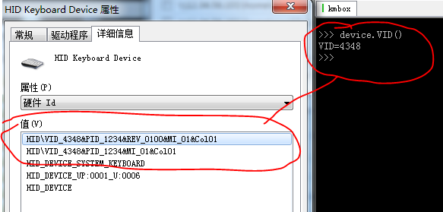

Type device.vid (' help ') to see how to use VID.

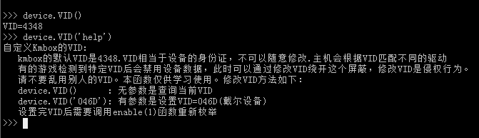

For example now change VID=046D(fake Logitech products).

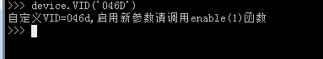

Changing the VID does not take effect immediately, you need to call device.enable(1). Have the computer re-identify the USB device.Your computer will re-enumerate after the call.

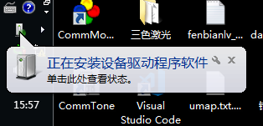

This is the perfect way to pass yourself off as Logitech's keyboard or mouse.The original VID lockdown against 4348 is, of course, gone.If he wants to seal 046D.It's up to the game company to have the guts.Again, VID infringement is illegal.Please do not arbitrarily modify it, or you will suffer the consequences.Thank you very much!

#### **How to modify PID**

A PID is a product number that is used to distinguish different products from the same company.Logitech, for example, has various models of keyboards and mice.They have the same VID, so use PID to differentiate.

The PID is modified in the same way as the VID.Refer to the help documentation for details.Kmbox PID = 0 x1234 by default

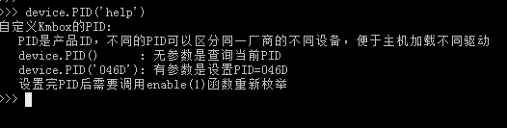

There are no more examples here.Try it yourself.

#### **How do I change a USB device name**

The default name of Kmbox is Kmbox.Some say the anti-plug-in mechanism may restrict the device based on the device name.So how do you change the name?In fact, you should know that most of the keyboard and mouse in order to save cost.There is no character descriptor for the device (need ROM storage).There is no device name by default.What if the device is actually disabled by device name?If you enable either of the VID and PID functions.The character description of Kmbox will be cleared.The host PC will not read the name of the device.Can not read the name can not be arbitrarily blocked, if blocked, on the reverse plug-in company has no mistake to kill 1000 can not let go of a courage.And personally feel that it is unlikely to identify the device according to the name.If I were an anti-plug-in programmer, I would start with VID and PID.Behavior detection predominates.Everything else is palliative rather than root cause.Therefore I do not provide the change name function.Kmbox wants to be themselves, or change VID and PID incognito.

### **Software against the seal**

In the previous hardware anti-blocking can solve the hardware reasons caused by the block, but there is a saying in the hardware field called: anti stupid not anti stupid.Many blocked numbers are not caused by hardware, but by software.For example, let's say you build a connecter that clicks the mouse 500 times per second for a day.It's impossible for a person to think about it. First, 500 clicks per second. Who can do that?10 times per second is not human.500 times is a no-brainer. It's definitely a plug-in.The second lasts a day.This is also unlikely.Still this high intensity of clicking for 1 day.So write hardware hang to try to simulate human operation.Use the hang must be installed like point.Don't be so fake.Discipline your behavior.When writing scripts, it's best to follow the actual situation, use random numbers, simulate the process, and keep everything under reasonable control.Here can only write their own script slowly to experience.It's all very empty.If you insist on clicking 500 times per second for a day.You've been banned.Don't tell me I don't have the hardware.I can't take the blame for this.And you contaminated the VID 0X4348.

To name a few examples of frequent fallibility:

1. Delays are too accurate.(The delay pattern of each keyboard and mouse event is too accurate.Not like a human operation.)
2. Keystroke time is too fast.(KmBox in order to improve code efficiency, a key command will have the fastest speed of execution (about 1ms), but the actual key, from press to lift, time at least 80ms above.Please try to simulate the key with Down and up simulation, less press)
3. The mouse movement span is too large.(try to split large span mouse moves into small span moves and use less code like move(800,600), instead use move(1,1) with 800 cycles in the X direction and 600 cycles in the y direction.)

All in all, try to act like a human being is doing it.So much for that, above!

### **Kmbox behavior mimicry**

In the behavior detection of the previous section, it is emphasized again and again that the plug-in should be able to install.Try to pretend to be human.So how do you make it look human?Kmbox offers a few simple but useful apis that will keep you from getting too mechanical.

1. Latency is too accurate.

Kmbox provides a random delay function for this.See Usage of the delay function for details

1. The keystroke time is too fast.

To specify how long the key will be held down.See Press function Usage for details.

1. The mouse movement span is too large.

Messy movement logic, with just a few parameters, Kmbox automatically turns mouse movement into a smooth curve.Instead of having to worry about straight, horizontal and vertical movements, Kmbox can move smoothly from start to finish.And you can do both different paths each time, and you can do specific smooth transitions.It's up to you.Kmbox's smooth transition principle is based on Bessel curves (see Baidu for more details).

Let's discuss move and moveto again.Move and moveto are given only two arguments.This represents a one-time quick move to a given coordinate.If you give three parameters.It means to fit with several broken lines from the start to the end.It is common sense that the higher the third parameter, the smoother the curve will be.And there are an infinite number of curves that pass the two points.So, when no other auxiliary constraints are given, each call to the function will have a different curve.This is the random curve of KmBox.If you want to control how warped the curve is.You can give a reference point coordinates.This reference point coordinate corrects the direction of the curve's distortion.Causes the curve to twist toward the reference point.So the move and moveto functions take three arguments or five arguments.The three parameters are randomly fitted to a Bessel curve. The five parameters are fitting a Bessel curve close to the reference point.I'm not a math teacher.You can run the script below yourself to see what each parameter does.It's better to hype than to actually see how it works.Demo script and video effect please go to the group sharing download.

Again:

1. Using multiple lines to fit a curve is definitely slower than a single horizontal vertical.At present, KMBox takes 1ms to fit each additional section of line.The longer the fitting length is, the smoother the curve will be, but the more time-consuming it will be.The smaller the fitting length, the more obvious the step of the curve inflection point.So it's best to fit the curve according to the actual situation.It is recommended to use 127 as the maximum scale unit to calculate how many fitting lines are needed.For example, moving from (0,0) to (1920, 1080) the maximum span is 1920 units.Then 1920 divided by 127 is 15.118. Therefore, the recommended minimum for the fitted line is 16.
2. Don't be alarmed.Currently KmBox is not restricted in any way, unless there is a need to simulate the process can be used to simulate the process, otherwise the script should be written as normal.Taobao on those software simulation hang all say oneself prevent block, do we this pure hardware stem but them?
3. If you do not know how to use the reference point to constrain the curve.It is recommended to simply use a function with three arguments.Set how many lines fit.The Kmbox will automatically randomly pick a reference point within the start and end range to automatically fit according to the fitting parameters.

## **The KMbox keyboard and mouse will record and play**

The principle of keyboard and mouse recording and playback is actually very simple, because the KMbox is straddled between the computer and the keyboard and mouse.In principle, all the keyboard and mouse data of the computer is sent by Kmbox to the PC.Therefore, the recording is equivalent to Kmbox actively reporting all the keyboard and mouse data, and the computer can complete the recording work by recording these data.Similarly, playback is to send the original recorded data to Kmbox, let him execute one by one, this is the playback operation.As you already know from the previous hardware knowledge, KmBox only has 4MB of internal storage space, and the memory is limited.It is not possible to store long recorded data.Therefore, KMBox borrows the capacity space of PC to realize the recording and storage of massive scripts.In this way, KMBox is not limited by its own RAM and ROM.Moreover, the communication between PC and KMBox is the only way for higher order applications.With PC as an extension, KMBox can achieve more advanced functions.For example, the function of finding pictures, color finding functions, AI map recognition and other functions.These KMbox can not be directly processed, but can be processed with a PC, so that the need to control the results of the Kmbox can be executed.

This section focuses on the serial communication of KmBox. Kmbox also supports network communication.This section of the host computer software source code, please go to the group sharing download.If you need other functions, you can refer to this procedure to add or modify.The compile environment is Microsoft Visual Studio 2010.

### **Keyboard recording**

Compile the generated file as: kmbox_recor.exe Double click to run:

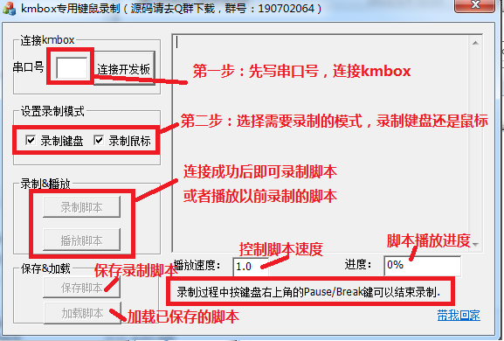

As shown in the image above, Kmbox communicates with a PC through a serial port, so this software needs to fill in the serial port number correctly.Refer to the previous section "Logging In to the KMBox" to find the serial port number.

3

Record script and load script button to unlock after properly connecting KmBox.The version number of KMBox will appear on the right.You can perform a recording script operation or load a previously recorded script.

Note: If the software does not connect to KmBox, check the following:

1. Make sure the serial port is not occupied by another program.If so, close other unrelated programs.
2. Make sure KmBox does not run any scripts internally.
3. Make sure KmBox is in the REPL state.

After clicking the recording script, all the specified data of Kmbox will be recorded in the right editing box.Look like this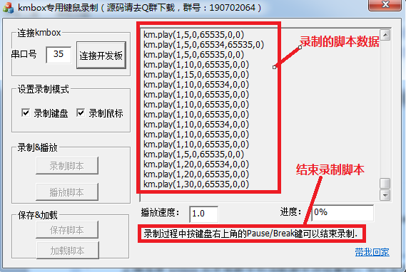Below:

To end recording, press Pause/Break on your keyboard.

### **Play the recording**

When you're done recording, the Play Script button unlocks and you can click on it to play what you just recorded.

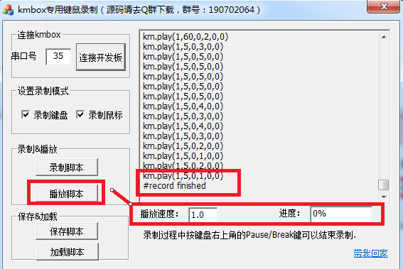

The playback button on the right can be used to speed up or slow down the script.Progress is used to show how much of the current script is playing.100% will be displayed when playback is complete.

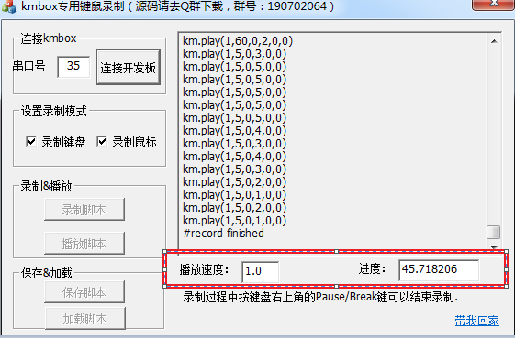

PS: Don't ask me how long I can record, it all depends on your computer configuration.As long as you have enough space to save the script.

### **Save the record**

Save Recording is used to save the recorded script file as a file for the next load call.

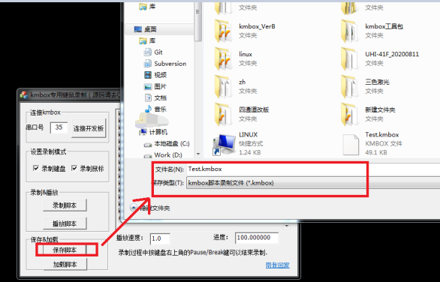

After clicking Save script as shown in the image, you can give your script a name and save it to your computer.

### **Load the recorded**

Loading a recording means re-reading the previously saved recording back into the software, which can then be executed by clicking Play script.Try it yourself.

Ps: This upper computer and Kmbox are used together.It cannot be used alone.Also please do not arbitrarily modify the recorded script.This recording script can also be burned to run inside KmBox, but be aware of capacity and memory limitations.

# **Kmbox other modules**

## **Kvm synchronizer, asynchronous**

Kmbox- KVM is an extension board that can achieve both keyboard and mouse synchronization and asynchronous function.With it, you can easily control four PCS synchronously and asynchronously with one set of keyboard and mouse (with the Kmbox main control board).The keyboard and mouse data of USB in all ports can be programmed.You can control the keyboard and mouse data of each computer at your whim.With KMBOX-KVM, you can easily move between four computers with one set of keys and mice.It is no longer a dream for one person to operate a team.Definitely move bricks, single brush, team under the copy of the artifact.

**Note: KVM expansion board must be used with KMBox motherboard.It will not work when purchased separately!**

### **Kmbox- Physical image of KVM expansion board**

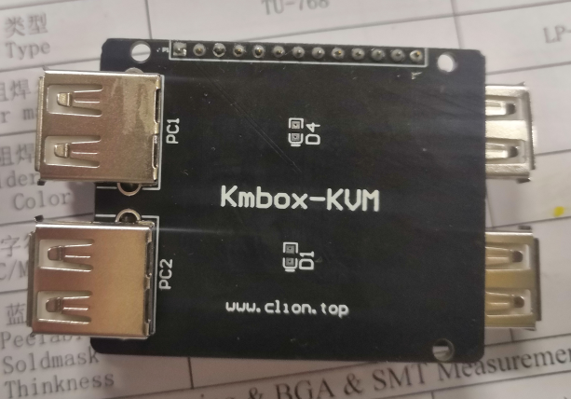

positive

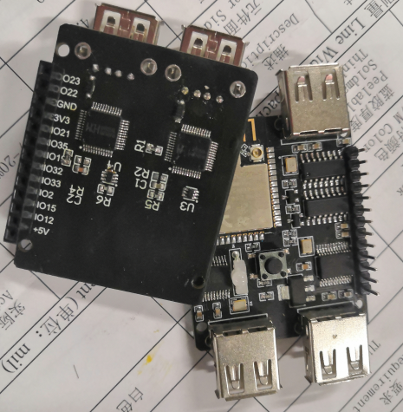

On the back

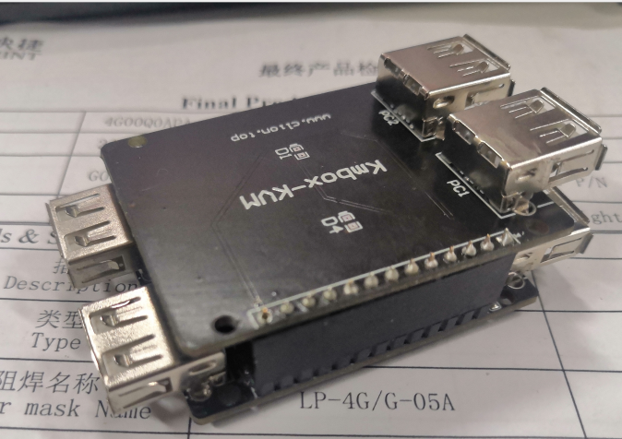

Tie-in kmbox

### **Kmbox- KVM expansion board function block diagram**

The Kvm expansion board contains two USB ports, one for USB1 and one for USB2.When connected to a computer, these two USB ports automatically mimic a keyboard and mouse (pure hardware keyboard and mouse, same as external keyboard and mouse).This keyboard and mouse is a standard HID keyboard and mouse, and there is no need to install any driver on the computer side.The USB1 and USB2 ports can connect two independent computers.The KVM extension board can be used to control the two PCS synchronously or asynchronously.The USB port data can be programmed.The programming is realized on KmBox motherboard.The Kvm expansion board is responsible for sending the keyboard and mouse data to different PCS.The KmBox-KVM can control a total of four computers.Dotted lines indicate Bluetooth control.

### **KVM extension board used**

The Kmbox motherboard already contains the KVM module. Before using it, you only need to import KVM, as shown in the following figure:

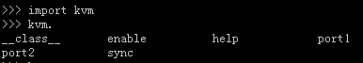

#### **Enable function (enable KVM module)**

Before using the Kvm module, you must first call the Enable function to complete initialization of the Kvm module.

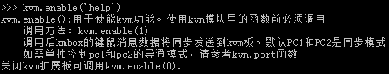

#### **Port1/2 function (keyboard and mouse data direction control)**

Port1,port2 functions are used to control which port the keyboard and mouse data goes to.Sometimes the keyboard and mouse operations only need to be sent to port1's computer instead of port2.You can use this function to enable port1 and disable port2. This will not affect the port2 port.It can be used as follows.

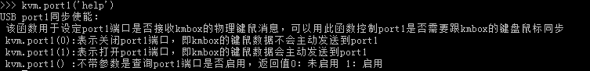

#### **The help function (help document)**

General help information will be displayed after typing KVM.help ().As with the KM module, you can use Kvm.xxx (' help ') for this function.

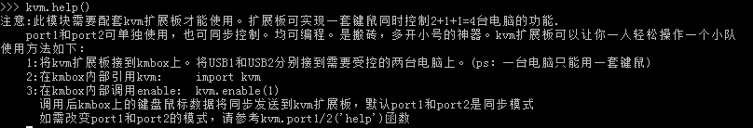

#### **Sync Button and mouse synchronization function**

The sync function can ignore the port1/2 toggle switch. For example, you expect the mouse data of USB1 and USB2 to be the same, but the keyboard data is different.You can use Sync (1) to achieve hard mouse synchronization.Keyboard data can be port1 and port2 independent.

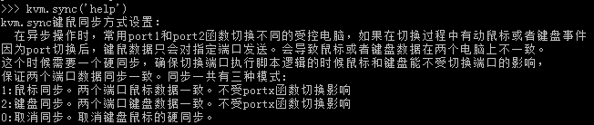

### **Typical application of Kvm expansion board**

#### **1. Programmable synchronizer**

Kvm extension board can switch the control mode arbitrarily, and the shortcut keys can be changed as you like.No more awkward screen cutters, anything you can define.You can switch between single screen and multiple screen synchronization.It's all up to your script.(Please go to the group to download the script)

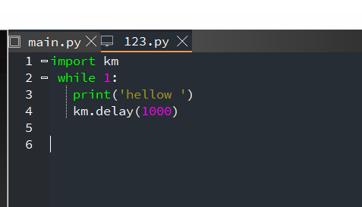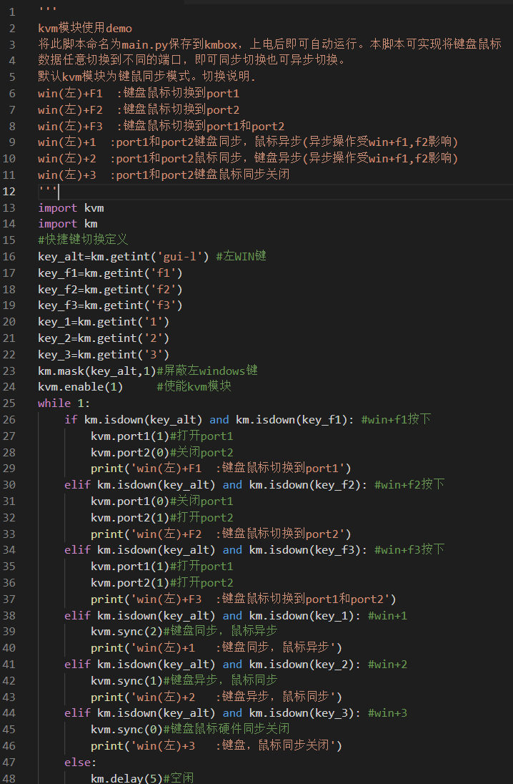

#### **Two, programmable asynchronous**

In addition to the synchronous function, the Kvm can be operated asynchronously.You may have used a synchronizer, but you may not have used an asynchronous.What is an asynchronous?Here's a simple example.Two PCS, a set of keyboard and mouse.Press the A key on the keyboard and PC#1 receives the A key and PC#2 receives the B key.For the same keyboard A pressed, two PCS receive different keys, which is called asynchrony.In the same way, a mouse can be asynchronous.What good is asynchrony, you might ask?It's all messed up.No, no, no.Asynchronizers do not copy keyboard and mouse messages as rigidly as synchronizers do.It can perform different operations for each computer.So it's more flexible.

For example: a game has 3 classes, warrior, mage, and Taoist.The warrior is melee, the mage is long-range, and the Taoist is a wet nurse.If there are three computers, each computer plays one of the classes.Assuming that you walk with a mouse, then synchronize the mice of all three computers.That's walking all three characters exactly the same.If you want to grind monsters level up.Mages ranged, good for quickly pulling monsters.Warrior melee, has close range AOE, Taoist can add health.So let's write a script like this.

1, press skill key 1, automatically switch to mage computer, lose remote pull strange skill.

2, at this time the warrior and Taoist priest do not do any processing, the monster is attacked automatically close to the mage.

3, delay for a while the warrior will automatically lose AOE group skills.Solve swarms of monsters.At the same time Taoist milk warrior and mage.

This can perfect play the advantages of the three professions, from the whole point of view, you only press a 1 key, at the same time control the three computers to do different things.The master pulls strange, the warrior hits the damage, the Taoist priest is responsible for the logistics supplement health.One person easily controls three characters.An asynchronous does something that a synchronizer can't do.A synchronizer can only operate one by one, but an asynchronizer can operate all three roles together.

Below is a simple keyboard asynchronous mouse synchronization demo (please go to group sharing to download the script).

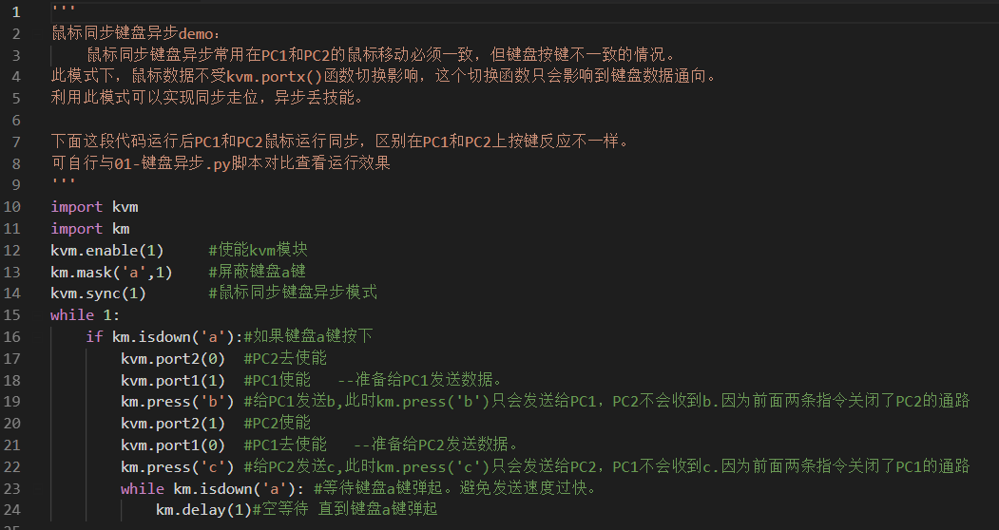

If you need other synchronous and asynchronous operations, write your own code.

## **BT Bluetooth mode**

Kmbox supports Bluetooth mode by default, but Bluetooth is not directly enabled. If you want to enable Bluetooth mode, you need to open the script software.In Bluetooth mode, the keyboard and mouse connected to KMBox can be directly transmitted to the host PC or mobile phone through Bluetooth.The wired keyboard and mouse can be Bluetooth-enabled.

### **How do I enable Bluetooth mode**

Starting Bluetooth mode requires the Import BT module.This is shown in the image below.

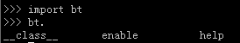

The Bluetooth module is relatively simple.There is only one help function and one enable function.

### **Help Bluetooth help function**

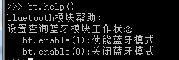

### **Enable Bluetooth enable function**

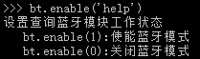

That is, to enable Bluetooth you only need to call bt.enable(1).Then there is the Bluetooth pairing of the host with KmBox.After the pairing is complete, it can be used normally.

If you want to start Bluetooth by default, through the previous learning you should know it.Just write the import bt and bt.enable(1) lines into boot.py.

## **Kmbox-nes(FC emulator)**

Kmbox can play NES games as well as make plug-ins.This is shown in the image below

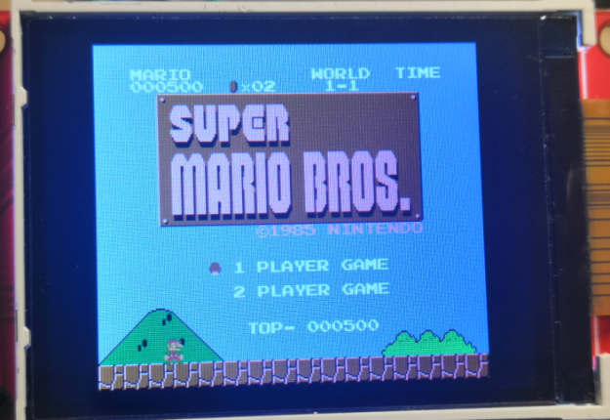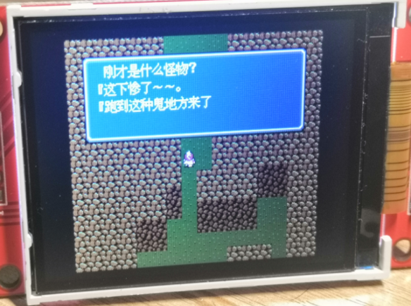

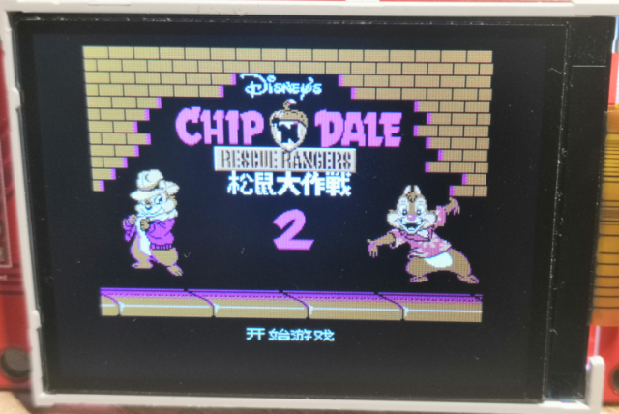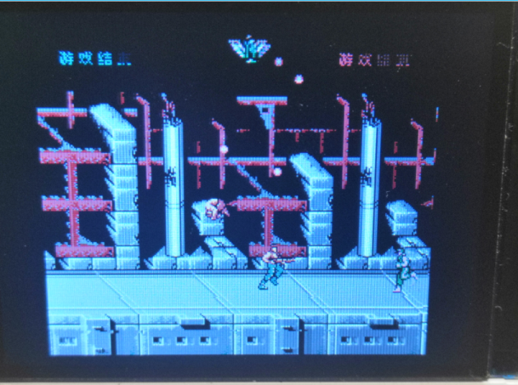

The required materials are as follows:

1. USB keyboard (when used with a gamepad)
2. One SPI serial port screen (driver chip ILI9341 resolution 320X240)
3. Game ROM(group shared download -- about 200+ games)

First you need to swipe the KmBox - NES firmware, please download directly from group sharing.Then find a game ROM that you want to play (the group has it or download it yourself).Swipe when ready :(note address)

**The firmware address is: 0x1000**

**ROM address is: 0x100000**

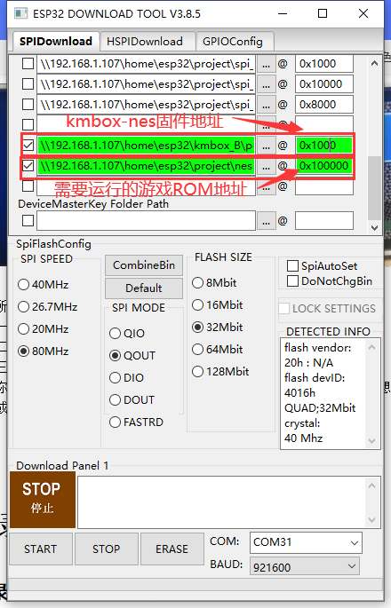

After burning, you can connect the keyboard to operate NES games.

The keyboard works as follows:

|  |  |  |  |  |  |
| --- | --- | --- | --- | --- | --- |
| The handle | The keyboard | The handle | The keyboard | The handle | The keyboard |
| In the direction | W or write | Button A | K or Spaces | Soft RESET | PgUp |
| Under the direction of | S or left | Button B | J | A hard RESET | Esc |
| The direction of the left | A or please | Select key  Select | Home |  |  |
| The right direction | D or - | Start button  Start | Insert or  The enter key |  |  |

# **The appendix**

## **Appendix 1. Corresponding Table of Keyboard Full key Values**

This table is the corresponding value of keyboard HID data and keys, which is the content of table function. On the left is the key name and on the right is the HEX value.If you are using keys that are not in the table function, remember to convert HEX to base 10 for use.

# define KEY_NONE 0 x00

# define KEY_ERRORROLLOVER 0 x01

# define KEY_POSTFAIL 0 x02

# define KEY_ERRORUNDEFINED 0 x03

# define KEY_A 0 x04

# define KEY_B 0 x05

# define KEY_C 0 x06

# define KEY_D 0 x07

# define KEY_E 0 x08

# define KEY_F 0 x09

# define KEY_G 0 x0a

# define KEY_H 0 x0b

# define KEY_I 0 x0c

# define KEY_J 0 x0d

# define KEY_K 0 x0e

# define KEY_L 0 x0f

# define KEY_M 0 x10

# define KEY_N 0 x11

# define KEY_O 0 x12

# define KEY_P 0 x13

# define KEY_Q 0 x14

# define KEY_R 0 x15

# define KEY_S 0 x16

# define KEY_T 0 x17

# define KEY_U 0 x18

# define KEY_V 0 x19

# define KEY_W 0 x1a

# define KEY_X 0 x1b

# define KEY_Y 0 x1c

# define KEY_Z 0 x1d

# define KEY_1_EXCLAMATION_MARK 0 x1e

# define KEY_2_AT 0 x1f

# define KEY_3_NUMBER_SIGN 0 x20

# define KEY_4_DOLLAR 0 x21

# define KEY_5_PERCENT 0 x22

# define KEY_6_CARET 0 x23

# define KEY_7_AMPERSAND 0 x24

# define KEY_8_ASTERISK 0 x25

# define KEY_9_OPARENTHESIS 0 x26

# define KEY_0_CPARENTHESIS 0 x27

# define KEY_ENTER 0 x28

# define KEY_ESCAPE 0 x29

# define KEY_BACKSPACE 0 x2a

# define KEY_TAB 0 x2b

# define KEY_SPACEBAR 0 x2c

# define KEY_MINUS_UNDERSCORE 0 x2d

# define KEY_EQUAL_PLUS 0 x2e

# define KEY_OBRACKET_AND_OBRACE 0 x2f

# define KEY_CBRACKET_AND_CBRACE 0 x30

# define KEY_BACKSLASH_VERTICAL_BAR 0 x31

# define KEY_NONUS_NUMBER_SIGN_TILDE 0 x32

# define KEY_SEMICOLON_COLON 0 x33

# define KEY_SINGLE_AND_DOUBLE_QUOTE 0 x34

# define KEY_GRAVE ACCENT AND TILDE 0 x35

# define KEY_COMMA_AND_LESS 0 x36

# define KEY_DOT_GREATER 0 x37

# define KEY_SLASH_QUESTION 0 x38

# define KEY_CAPS LOCK 0 x39

# define KEY_F1 0 x3a

# define KEY_F2 0 x3b

# define KEY_F3 0 x3c

# define KEY_F4 0 x3d

# define KEY_F5 0 x3e

# define KEY_F6 0 x3f

# define KEY_F7 0 x40

# define KEY_F8 0 x41

# define KEY_F9 0 x42

# define KEY_F10 0 x43

# define KEY_F11 0 x44

# define KEY_F12 0 x45

# define KEY_PRINTSCREEN 0 x46

The LOCK 0 # define KEY_SCROLL x47

# define KEY_PAUSE 0 x48

# define KEY_INSERT 0 x49

# define KEY_HOME 0 x4a

# define KEY_PAGEUP 0 x4b

# define KEY_DELETE 0 x4c

# define KEY_END1 0 x4d

# define KEY_PAGEDOWN 0 x4e

# define KEY_RIGHTARROW 0 x4f

# define KEY_LEFTARROW 0 x50

# define KEY_DOWNARROW 0 x51

# define KEY_UPARROW 0 x52

# define KEY_KEYPAD_NUM_LOCK_AND_CLEAR 0 x53

# define KEY_KEYPAD_SLASH 0 x54

# define KEY_KEYPAD_ASTERIKS 0 x55

# define KEY_KEYPAD_MINUS 0 x56

# define KEY_KEYPAD_PLUS 0 x57

# define KEY_KEYPAD_ENTER 0 x58

# define KEY_KEYPAD_1_END 0 x59

# define KEY_KEYPAD_2_DOWN_ARROW 0 x5a

# define KEY_KEYPAD_3_PAGEDN 0 x5b

# define KEY_KEYPAD_4_LEFT_ARROW 0 x5c

# define KEY_KEYPAD_5 0 x5d

# define KEY_KEYPAD_6_RIGHT_ARROW 0 x5e

# define KEY_KEYPAD_7_HOME 0 x5f

# define KEY_KEYPAD_8_UP_ARROW 0 x60

# define KEY_KEYPAD_9_PAGEUP 0 x61

# define KEY_KEYPAD_0_INSERT 0 x62

# define KEY_KEYPAD_DECIMAL_SEPARATOR_DELETE 0 x63

# define KEY_NONUS_BACK_SLASH_VERTICAL_BAR 0 x64

# define KEY_APPLICATION 0 x65

# define KEY_POWER 0 x66

# define KEY_KEYPAD_EQUAL 0 x67

# define KEY_F13 0 x68

# define KEY_F14 0 x69

# define KEY_F15 0 x6a

# define KEY_F16 0 x6b

# define KEY_F17 0 x6c

# define KEY_F18 0 x6d

# define KEY_F19 0 x6e

# define KEY_F20 0 x6f

# define KEY_F21 0 x70

# define KEY_F22 0 x71

# define KEY_F23 0 x72

# define KEY_F24 0 x73

# define KEY_EXECUTE 0 x74

# define KEY_HELP 0 x75

# define KEY_MENU 0 x76

# define KEY_SELECT 0 x77

# define KEY_STOP 0 x78

# define KEY_AGAIN 0 x79

# define KEY_UNDO 0 x7a

# define KEY_CUT 0 x7b

# define KEY_COPY 0 x7c

# define KEY_PASTE 0 x7d

# define KEY_FIND 0 x7e

# define KEY_MUTE 0 x7f

# define KEY_VOLUME_UP 0 x80

# define KEY_VOLUME_DOWN 0 x81

# define KEY_LOCKING_CAPS_LOCK 0 x82

# define KEY_LOCKING_NUM_LOCK 0 x83

# define KEY_LOCKING_SCROLL_LOCK 0 x84

# define KEY_KEYPAD_COMMA 0 x85

# define KEY_KEYPAD_EQUAL_SIGN 0 x86

# define KEY_INTERNATIONAL1 0 x87

# define KEY_INTERNATIONAL2 0 x88

# define KEY_INTERNATIONAL3 0 x89

# define KEY_INTERNATIONAL4 0 x8a

# define KEY_INTERNATIONAL5 0 x8b

# define KEY_INTERNATIONAL6 0 x8c

# define KEY_INTERNATIONAL7 0 x8d

# define KEY_INTERNATIONAL8 0 x8e

# define KEY_INTERNATIONAL9 0 x8f

# define KEY_LANG1 0 x90

# define KEY_LANG2 0 x91

# define KEY_LANG3 0 x92

# define KEY_LANG4 0 x93

# define KEY_LANG5 0 x94

# define KEY_LANG6 0 x95

# define KEY_LANG7 0 x96

# define KEY_LANG8 0 x97

# define KEY_LANG9 0 x98

# define KEY_ALTERNATE_ERASE 0 x99

# define KEY_SYSREQ 0 x9a

# define KEY_CANCEL 0 x9b

# define KEY_CLEAR 0 x9c

# define KEY_PRIOR 0 x9d

# define KEY_RETURN 0 x9e

# define KEY_SEPARATOR 0 x9f

# define KEY_OUT 0 xa0

# define KEY_OPER 0 xa1

# define KEY_CLEAR_AGAIN 0 xa2

# define KEY_CRSEL 0 xa3

# define KEY_EXSEL 0 xa4

# define KEY_KEYPAD_00 0 xb0

# define KEY_KEYPAD_000 0 xb1

# define KEY_THOUSANDS_SEPARATOR 0 sets

# define KEY_DECIMAL_SEPARATOR 0 xb2

# define KEY_CURRENCY_UNIT 0 xb4

# define KEY_CURRENCY_SUB_UNIT 0 xb5

# define KEY_KEYPAD_OPARENTHESIS 0 xb6

# define KEY_KEYPAD_CPARENTHESIS 0 xb7

# define KEY_KEYPAD_OBRACE 0 xb8

# define KEY_KEYPAD_CBRACE 0 xb9

# define KEY_KEYPAD_TAB 0 xba

# define KEY_KEYPAD_BACKSPACE 0 XBB

# define KEY_KEYPAD_A 0 XBC

# define KEY_KEYPAD_B 0 XBD

# define KEY_KEYPAD_C 0 xbe

# define KEY_KEYPAD_D 0 XBF

# define KEY_KEYPAD_E 0 xc0

# define KEY_KEYPAD_F 0 xc1

# define KEY_KEYPAD_XOR 0 xc2

# define KEY_KEYPAD_CARET 0 xc3

# define KEY_KEYPAD_PERCENT 0 xc4

# define KEY_KEYPAD_LESS 0 xc5

# define KEY_KEYPAD_GREATER 0 xc6

# define KEY_KEYPAD_AMPERSAND 0 xc7

# define KEY_KEYPAD_LOGICAL_AND 0 xc8

# define KEY_KEYPAD_VERTICAL_BAR 0 xc9

# define KEY_KEYPAD_LOGIACL_OR 0 xca

# define KEY_KEYPAD_COLON 0 XCB

# define KEY_KEYPAD_NUMBER_SIGN 0 XCC

# define KEY_KEYPAD_SPACE 0 XCD

# define KEY_KEYPAD_AT 0 xce

# define KEY_KEYPAD_EXCLAMATION_MARK 0 XCF

# define KEY_KEYPAD_MEMORY_STORE 0 xd0

# define KEY_KEYPAD_MEMORY_RECALL 0 xd1

# define KEY_KEYPAD_MEMORY_CLEAR 0 xd2

# define KEY_KEYPAD_MEMORY_ADD 0 xd3

# define KEY_KEYPAD_MEMORY_SUBTRACT 0 xd4

# define KEY_KEYPAD_MEMORY_MULTIPLY 0 xd5

# define KEY_KEYPAD_MEMORY_DIVIDE 0 xd6

# define KEY_KEYPAD_PLUSMINUS 0 xd7

# define KEY_KEYPAD_CLEAR 0 xd8

# define KEY_KEYPAD_CLEAR_ENTRY 0 xd9

# define KEY_KEYPAD_BINARY 0 xda

# define KEY_KEYPAD_OCTAL 0 XDB

# define KEY_KEYPAD_DECIMAL 0 XDC

# define KEY_KEYPAD_HEXADECIMAL 0 XDD

# define KEY_LEFTCONTROL 0 xe0-0xfc

# define KEY_LEFTSHIFT 0 xe1

# define KEY_LEFTALT 0 xe2

# define KEY_LEFT_GUI 0 xe3

# define KEY_RIGHTCONTROL 0 xe4

# define KEY_RIGHTSHIFT 0 xe5

# define KEY_RIGHTALT 0 xe6

# define KEY_RIGHT_GUI 0 xe7

## **Appendix 2. Kmbox Structure Size diagram**

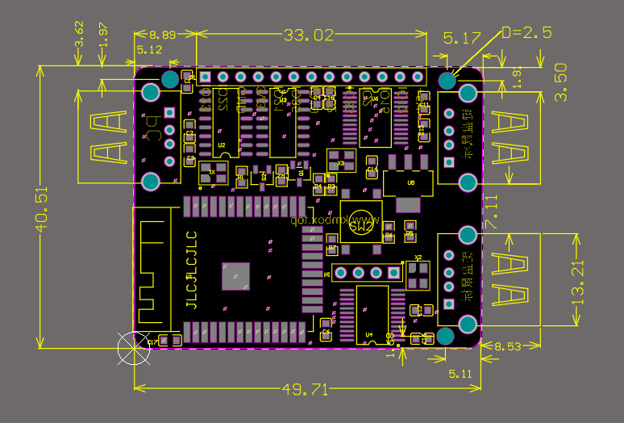

# **Solutions to common problems**

## **The keyboard and mouse will not work properly**

When the keyboard or mouse connected to the KMbox can not work properly, please do not panic, the problem is not big, KMbox as a host, needs to be compatible with all keyboards and mice, the author has limited equipment, there are thousands of keyboards and mice on the market.There is no way to know its features.So remember to turn on the serial port.Plug in your USB device.You will almost certainly see the following line printed.

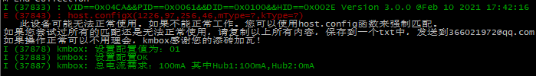

Here are two ways to make your keyboard and mouse work:

Method 1: Call the host.configx function.Debug which argument fits your keyboard and mouse by typing import host in the console.There are two config functions in the host module, config0 and config1. Because Kmbox has two USB ports.These two USB ports will work for a keyboard or mouse.The configX (X=0 or 1) function is used to enforce USB configuration properties for both ports.The first four parameters of configX you can get from log.

E (37843) : host. ConfigX (1226,97,256,46, mType =?,kType=?) Among them

MType: indicates the mouse report parsing mode. The value ranges from 0 to 12.

KType: keyboard report resolution mode. The value ranges from 0 to 6.

If the mouse is not working properly, you need to change the value of mType, which ranges from 0 to 12. You can set the value of mType to one of the values from 0 to 12.After the call, see if the mouse works properly.If it does, then the mType value for your mouse has been determined. If the keyboard doesn't work, change the value of kType in turn.Until the keyboard works properly.

Note:

1. The wireless keyboard and mouse receiver is connected to the KMBox and will receive keyboard and mouse data in the receiver.You need to set both the mType and kType values.If your device is a pure keyboard, then set the value of mType to 255. If your device is a pure mouse, then set the value of kType to 255.
2. Config0 and Config1 do not correspond to USB ports, they correspond to devices.The device can be plugged into any USB port.If you have a device that is unavailable, you used Config0 to force a match.For the second unusable device you need to use the config1 function.If you continue using the config0 function, you will wash out config0's configuration.Kmbox controls at most two devices.Config0 and Config1 are used to correspond to these two devices.

After you have successfully adapted the keyboard and mouse using the above method, you can create a config.py file.Write the configuration values into the config.py file.Then download it to the development board.Then it can be automatically identified and matched permanently later.Here's what it looks like:

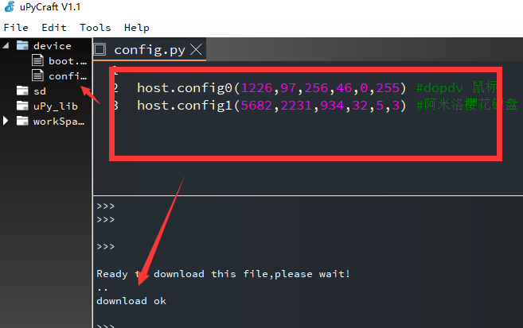

Restart the development board after downloading to automatically identify:

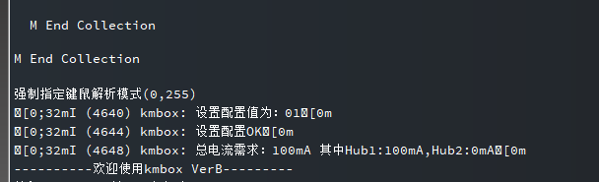

If you try to match all the key and mouse parameters, it still doesn't work properly.Then please copy all the printed content to a TXT file.Name it after the device name.For example, the Logitech G102 mouse is not recognizable.Please copy all prints and name them "Logitech G102 mouse.txt" (below).And send the file to the author to be supported after adding adaptations.

## **The serial port of the keyboard and mouse is disconnected once it is inserted and removed**

This is typically a lack of power supply problem.Do not connect the USB1 port of the Kmbox to any HUB, extender.Make sure you connect it directly to the USB port on your computer.And make sure the USB port is fully powered.

Common sense: a USB port supply voltage is 5V, the maximum current is 500mA. When the computer USB connected to the KMbox, KMbox then connected to the keyboard or mouse, the power supply or computer USB.Kmbox needs to consume 100mA current (Bluetooth mode 300mA). If your keyboard and mouse consumes large amounts of current, its total current requirement plus the KmBox's exceeds 500mA. Then the Kmbox may not work properly.Because your computer's USB port won't provide enough current.Make sure the USB port is fully powered.

The keyboard and mouse demand current can be found in the boot log, KmBox does not do power management.By default, your computer has sufficient power supply:

I (161224) kmbox: = = = = = = = = = = configuration descriptor start = = = = = = = = = =

I (161230) kmbox: bLength: 09

I (161234) kmbox: bDescriptorType: 02(fixed at 02)

I (161240) kmbox: wTotalLengthH/L: 0054(set length)

I (161246) kmbox: bNumInterfaces: 03(number of interfaces)

I (161251) kmbox: bConfigValue: 01(configuration value)

I (161257) kmbox: iConfiguration: 04(configuration character index)

I (161263) KmBox: bmAttributes: A0(bus powered to support remote wake up)

I (161270) KmBox: MaxPower: 31(Max current 98mA)

Make sure that the total current of all devices is less than 500mA of USB specification and that your computer can provide sufficient current.

The total current requirement prompt is now integrated with the board.

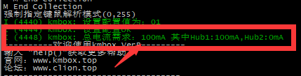

If the total current is greater than 500mA, the kmbox may not work properly.The keyboard and mouse in the back may not work properly either.After all, a USB current is only 500mA. Originally, the keyboard and mouse are powered by separate ports.Now one USB port powers the Kmbox, the external keyboard and the external mouse.If this happens it is recommended to use a dual port USB cable to improve the USB power supply capability.The two-port USB cable is connected as follows:

## **After plugging in the board card, it will not stop restarting**

This may be the serial driver installation error caused by frequent board restart, please download the group of drivers.